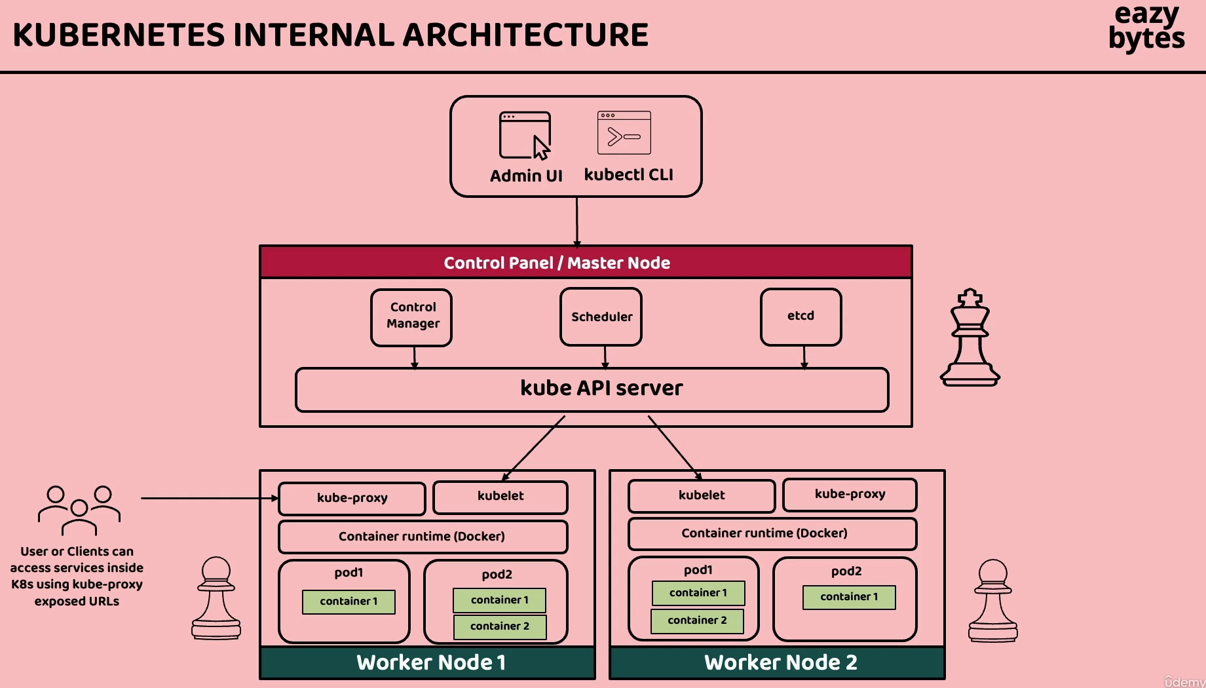

Kuebrntes has masternode and server node

222) inside local Kubernetes setup kubernets dashboard:

1) install helm with choclatey  
 choco install kubernetes-helm

2) helm repo add kubernetes-dashboard <https://kubernetes.github.io/dashboard/>

3) helm upgrade --install kubernetes-dashboard kubernetes-dashboard/kubernetes-dashboard --create-namespace --namespace kubernetes-dashboard

4)<https://localhost:8443> to open kubernets dashboard

224) you will deploy ms without helm:

kubectl get services  
see section 15, code of configserver.yaml where kind= deployment and kind=service code

to get default namespaces: kubectl get replicaset

C:\WINDOWS\system32>kubectl get ns

NAME STATUS AGE

default Active 2d22h

kube-node-lease Active 2d22h

kube-public Active 2d22h

kube-system Active 2d22h

kubernetes-dashboard Active 123m

**command for running configserver.yml file is:**

**kubectl apply -f configserver.yml**

you can check now: kubectl get sercies, kubectl get deployments, kubectl get replicasets, kubectl get pods

apiVersion: apps/v1  
kind: Deployment  
metadata:  
 name: configserver-deployment  
 labels:  
 app: configserver  
spec:  
 replicas: 1  
 selector:  
 matchLabels:  
 app: configserver  
 template:  
 metadata:  
 labels:  
 app: configserver  
 spec:  
 containers:  
 - name: configserver  
 image: eazybytes/configserver:s12  
 ports:  
 - containerPort: 8071  
---  
apiVersion: v1  
kind: Service  
metadata:  
 name: configserver  
spec:  
 selector:  
 app: configserver  
 type: LoadBalancer  
 ports:  
 - protocol: TCP  
 port: 8071  
 targetPort: 8071

225) deploy all remaining microsevices in to Kubernetes cluster

Create envieronmnet variables file using configMap

apiVersion: v1  
kind: ConfigMap  
metadata:  
 name: eazybank-configmap  
data:  
 SPRING_PROFILES_ACTIVE: prod  
 SPRING_CONFIG_IMPORT: "configserver:http://configserver:8071/"  
 EUREKA_CLIENT_SERVICEURL_DEFAULTZONE: "http://eurekaserver:8070/eureka/"  
 CONFIGSERVER_APPLICATION_NAME: configserver  
 EUREKA_APPLICATION_NAME: eurekaserver  
 ACCOUNTS_APPLICATION_NAME: accounts  
 LOANS_APPLICATION_NAME: loans  
 CARDS_APPLICATION_NAME: cards  
 GATEWAY_APPLICATION_NAME: gatewayserver  
 KEYCLOAK_ADMIN: admin  
 KEYCLOAK_ADMIN_PASSWORD: admin  
 SPRING_SECURITY_OAUTH2_RESOURCESERVER_JWT_JWK-SET-URI: "http://keycloak:7080/realms/master/protocol/openid-connect/certs"

**226) preparing kubernets manifest files to deploy in kuberrnets**

227) **deplopying all remaining microsevcie yaml files in to kubnerntes**

Kubectl apply -f yamlfilename.yaml

228) **automatic self healing inside kubernets cluster**

Kubectl get replicaset

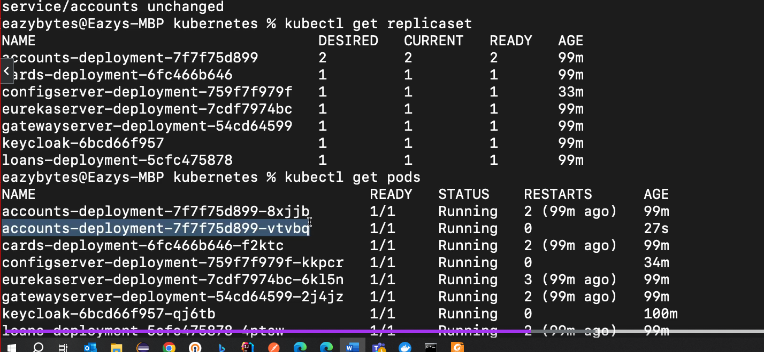

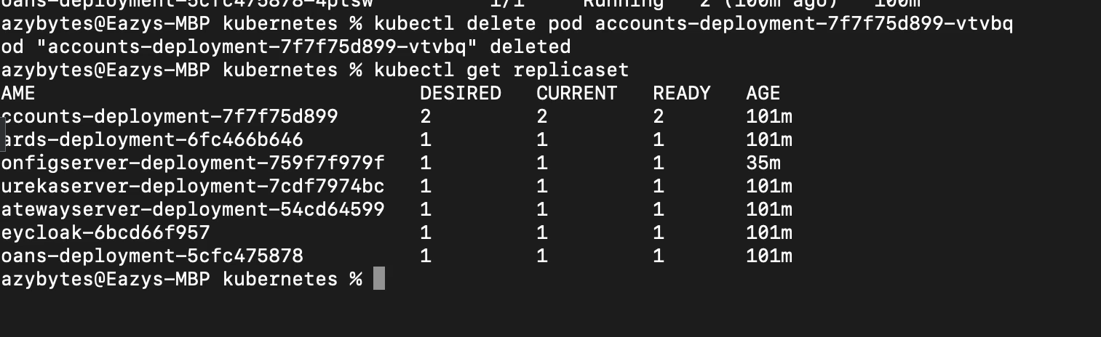

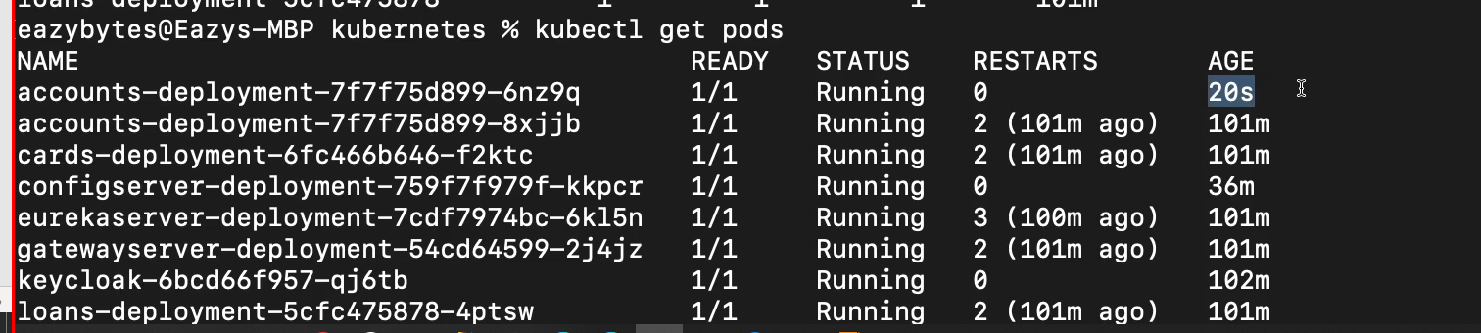



229) Autmatic rollout and roolback inside kuberntes cluster

To update replicas in kuberners not in yaml file but another way:



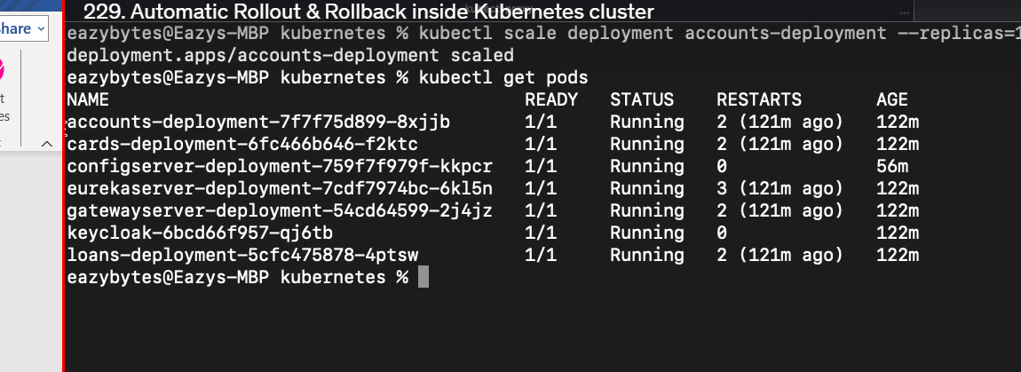

ROLLOUT WITHOUT DOWNTIME.



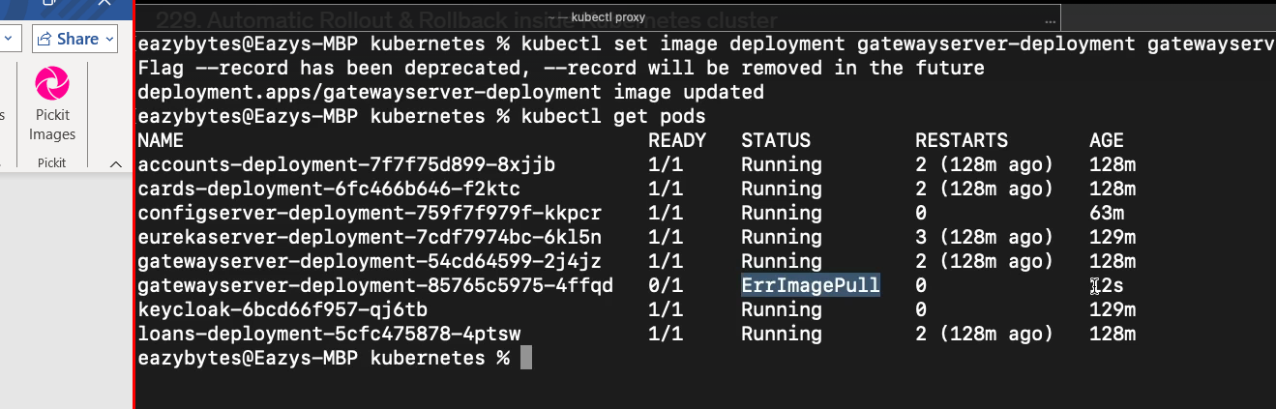

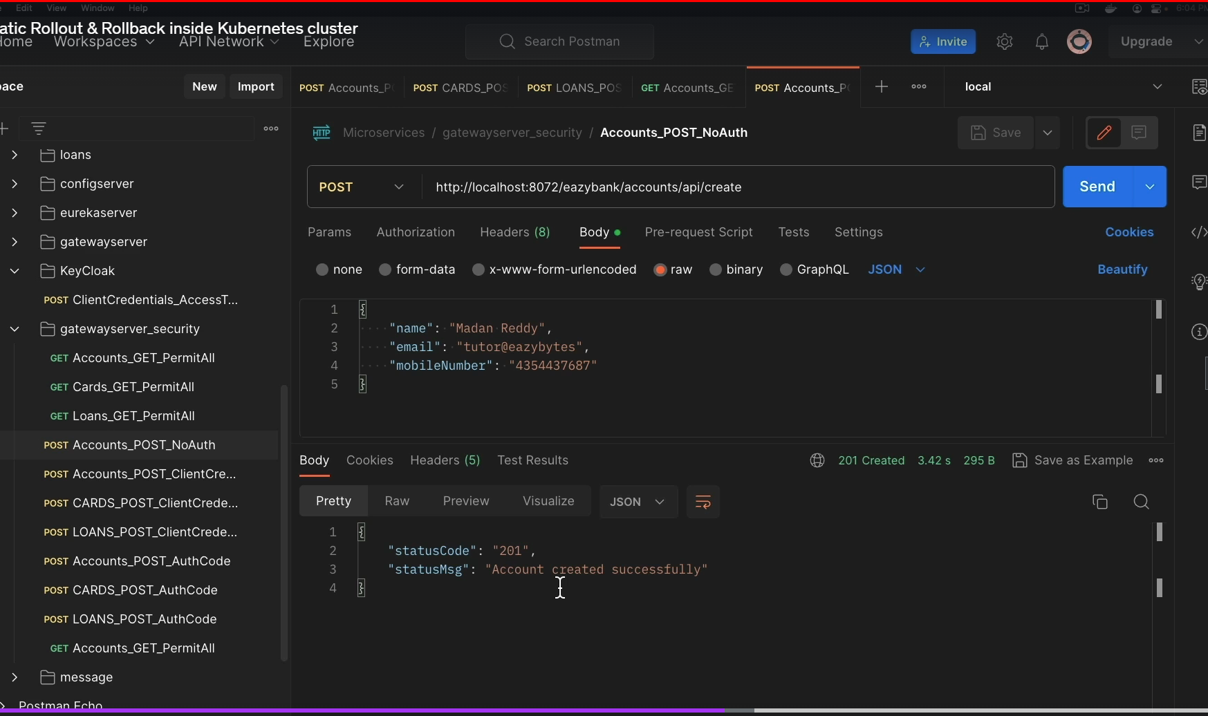

To rollback to the previous image:

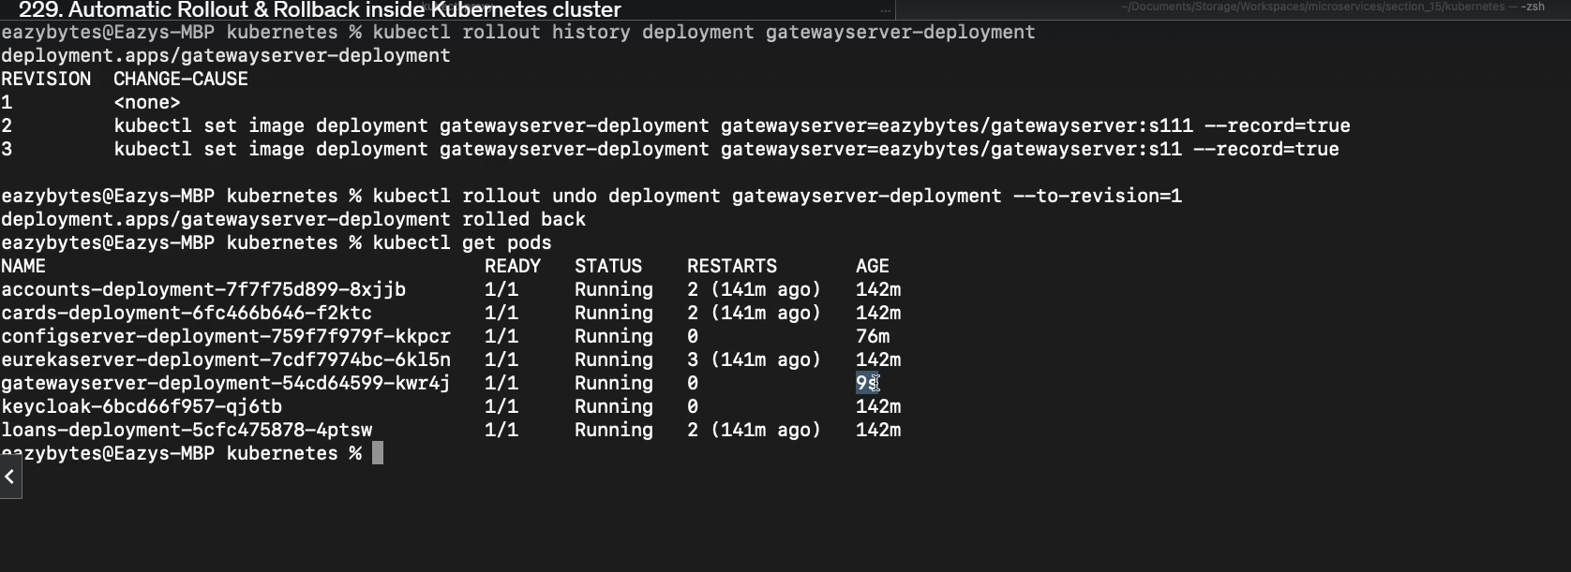

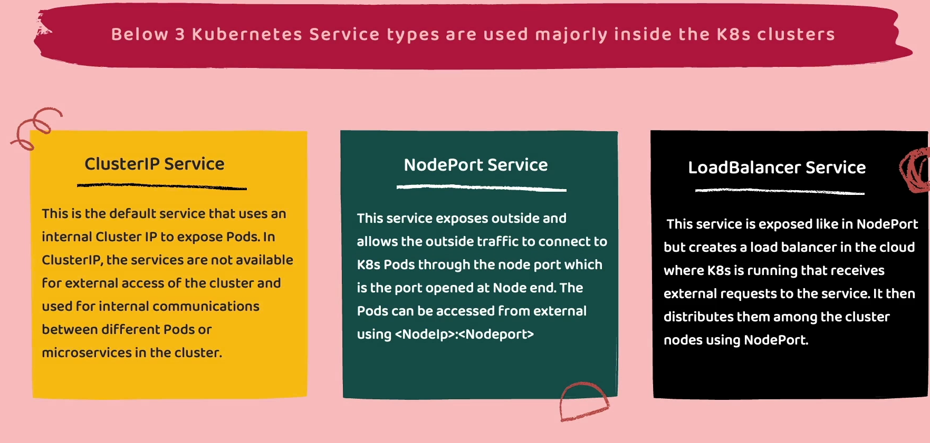

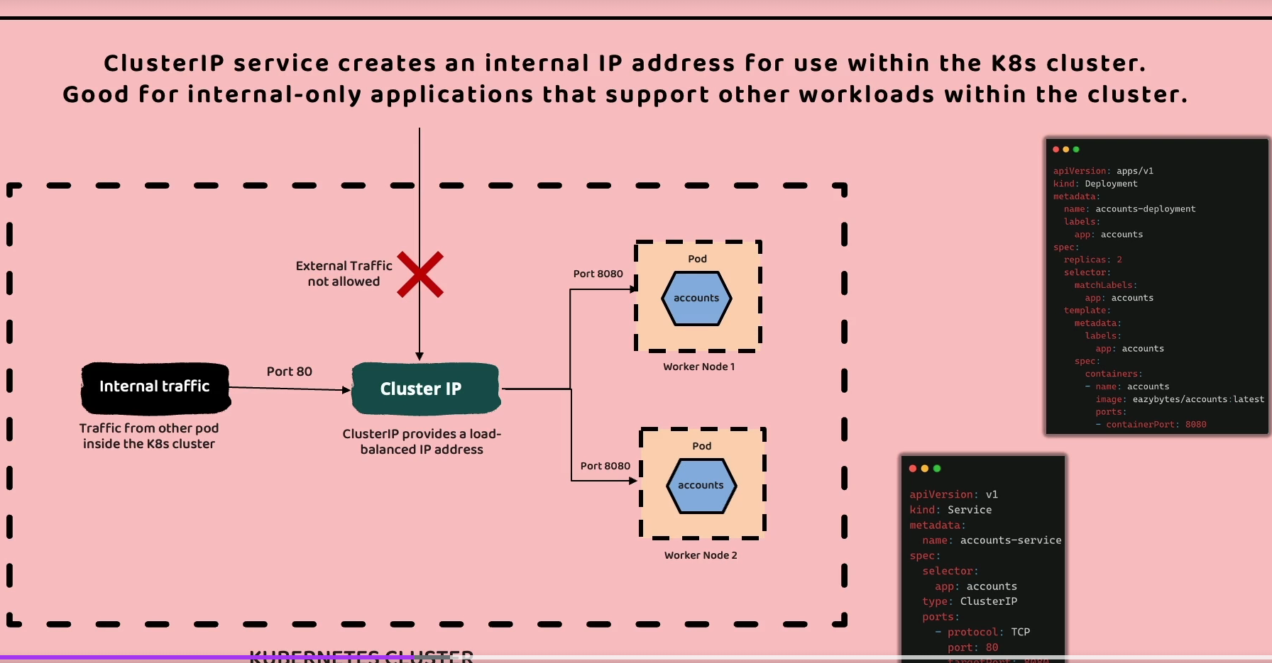

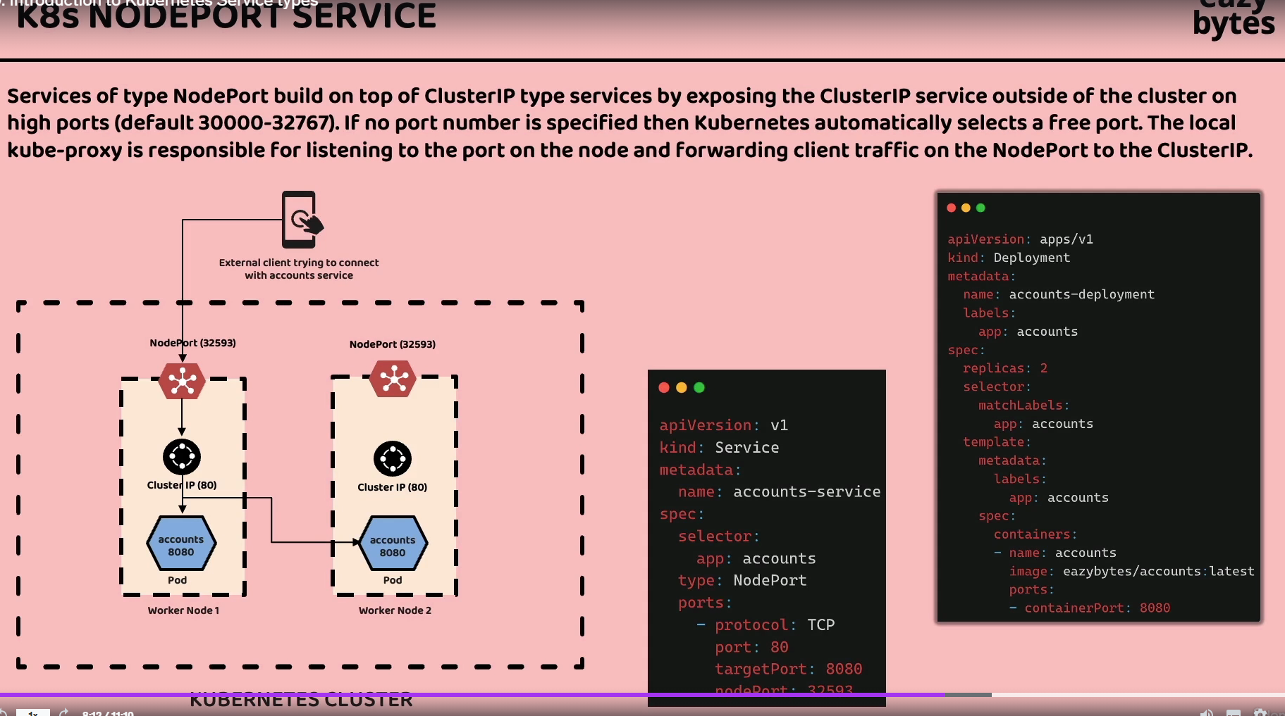

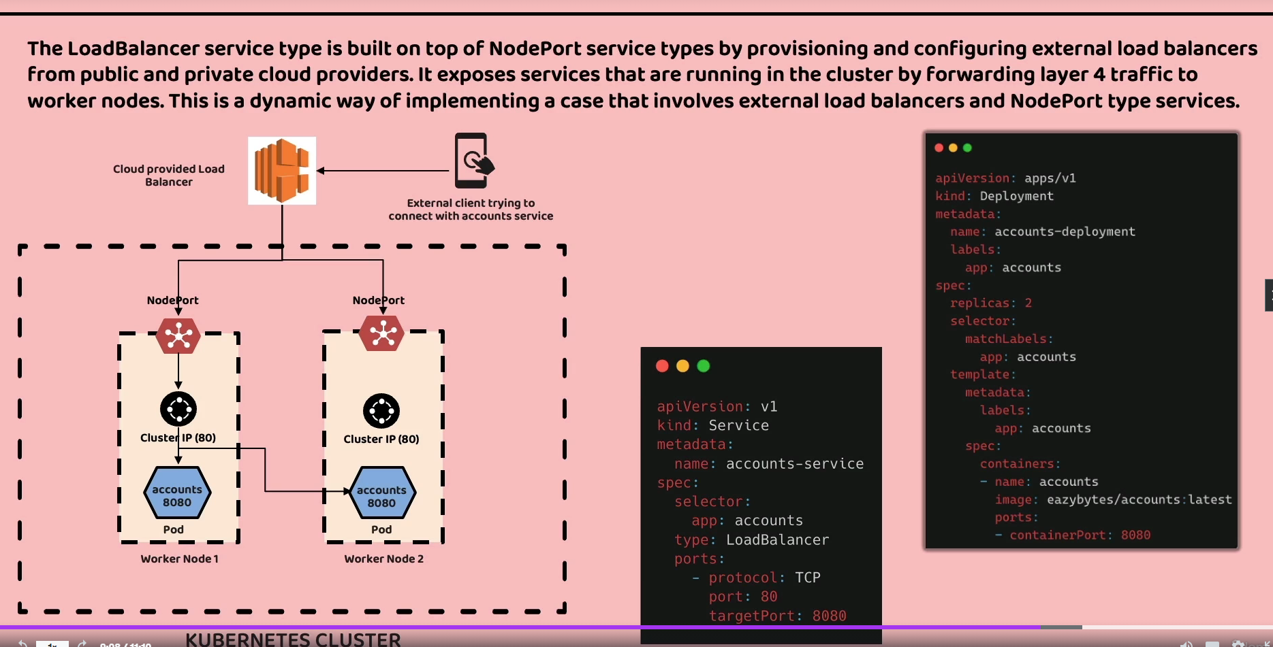

231) Kubernetes service types

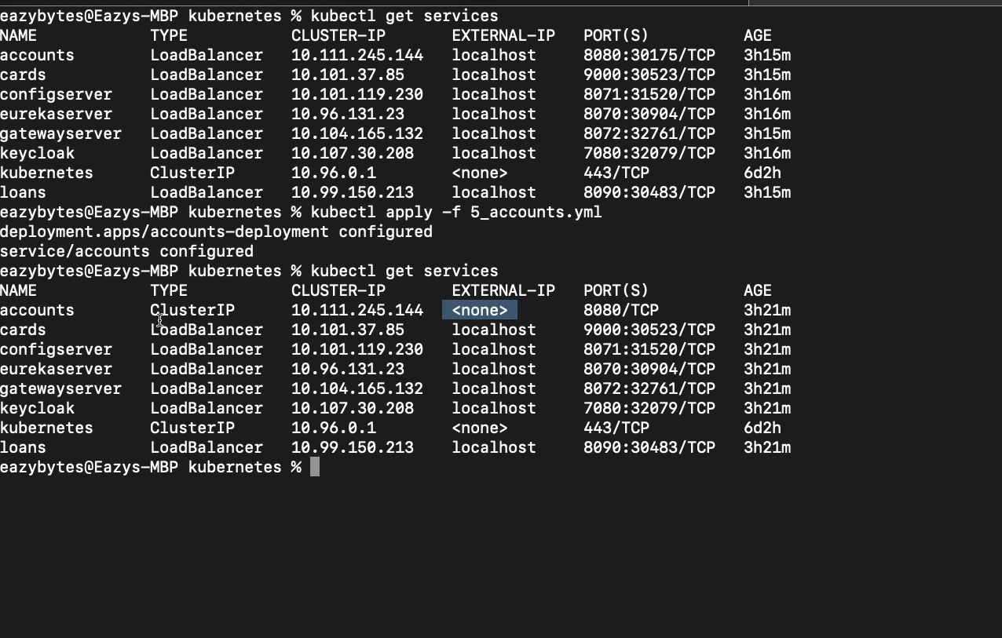

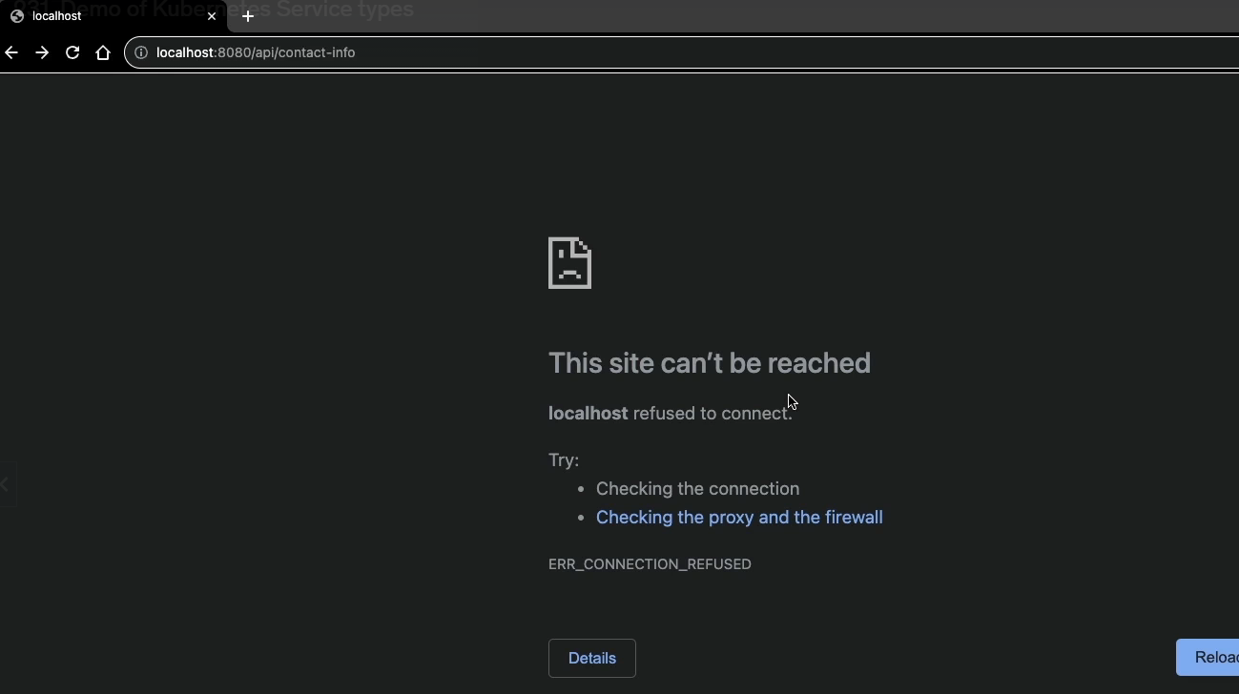

You cannot access account ms from above screen shot when type is clusterIP

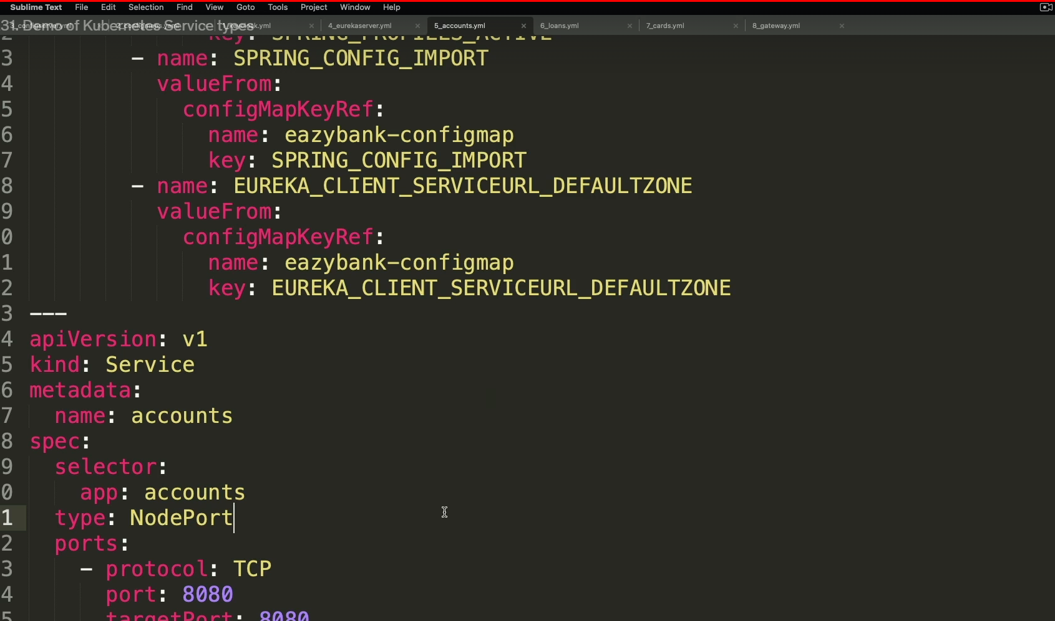

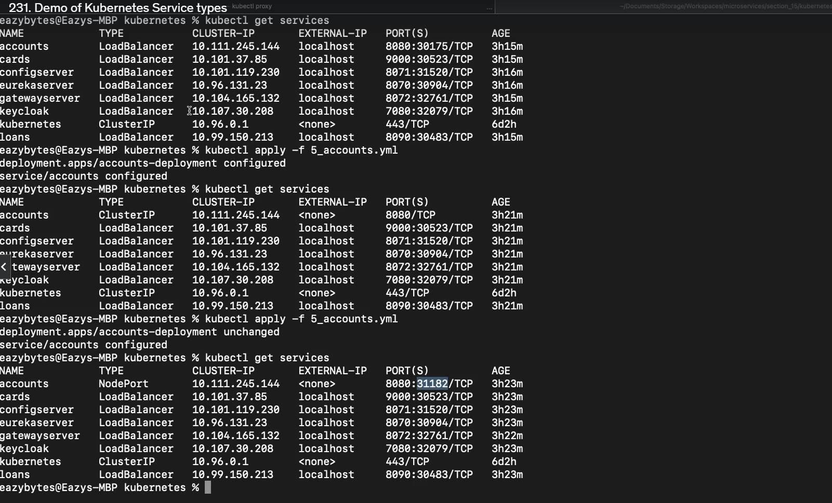  
  
  
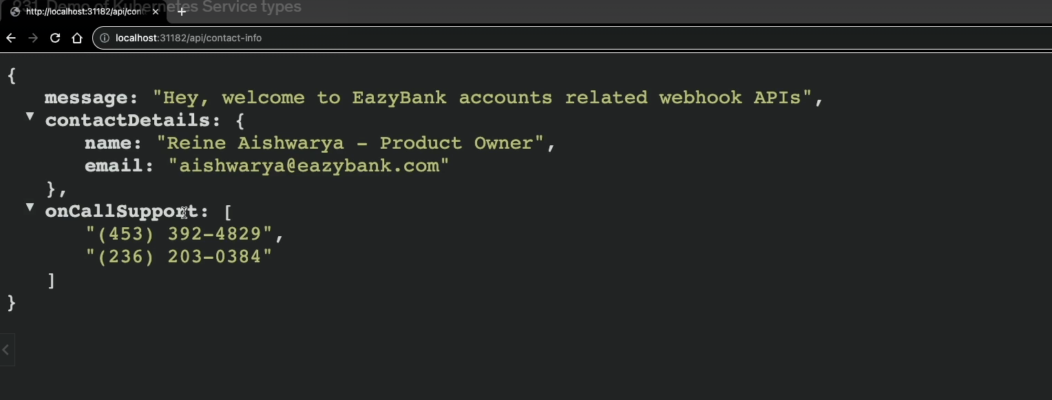

You can access through node port (31182) now when type is nodeport

When he is deploying mcirosevces, he will use type as clusterIp for every ms except the apigateway. For apigateway he uses “loadbalancer type”

Reason: when you use all microservcics as loadbalcner type, you exposing it through public Ip, now it costlier in cloud when you have too many public ips. And also it is not necessary to expose every ms through public ip.

232)

238)

Helm chart creation for accounts ms

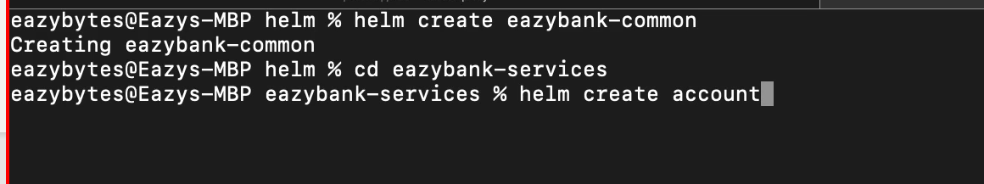

We use easybank common to build helmchart for account ms

After helm create accounts, delete all files in templates folder and then values.yaml content

Go to chart.yaml change appversion to 1.0.0.

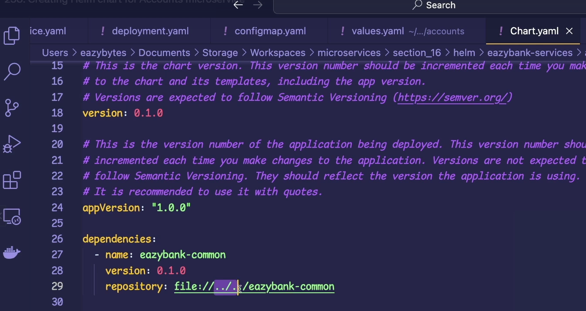

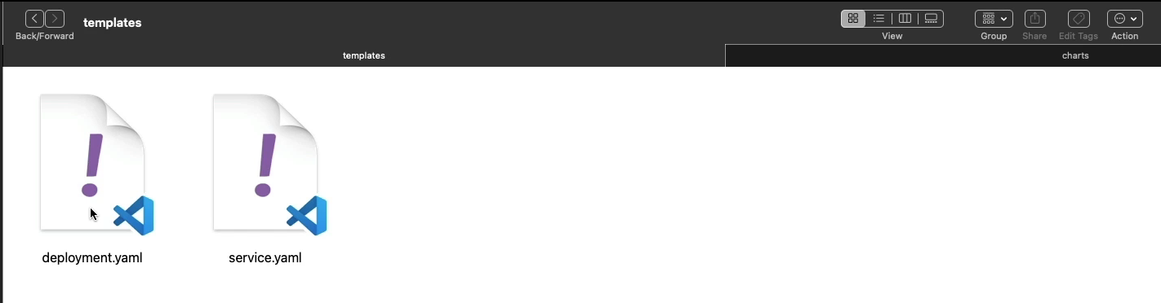

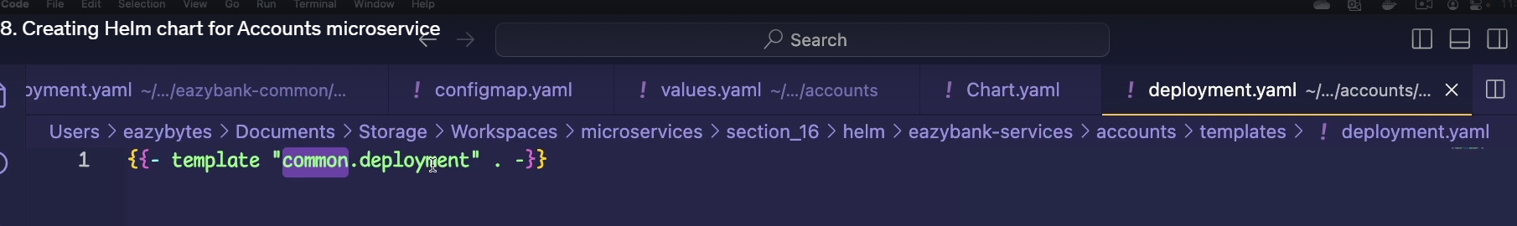

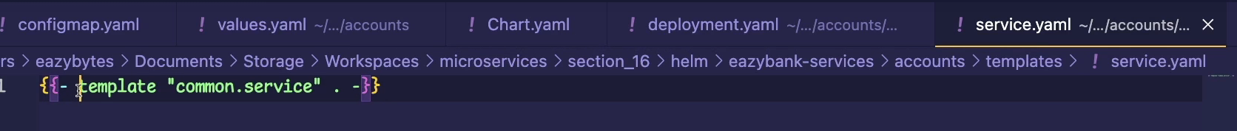

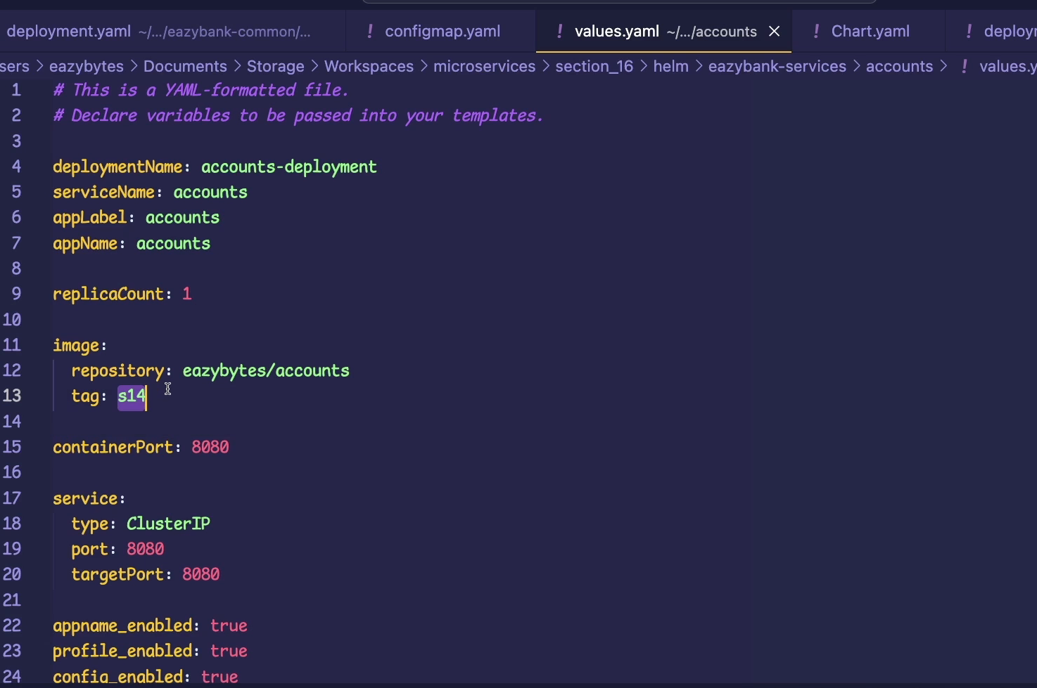

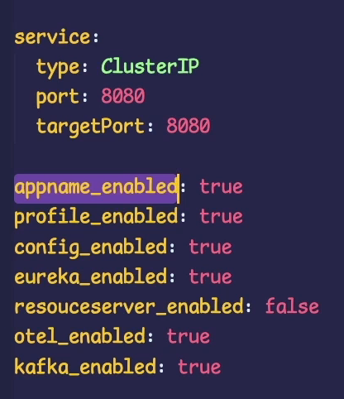

239) helm chart for other ms

Copy the account repo and just do required modiications in values.yaml

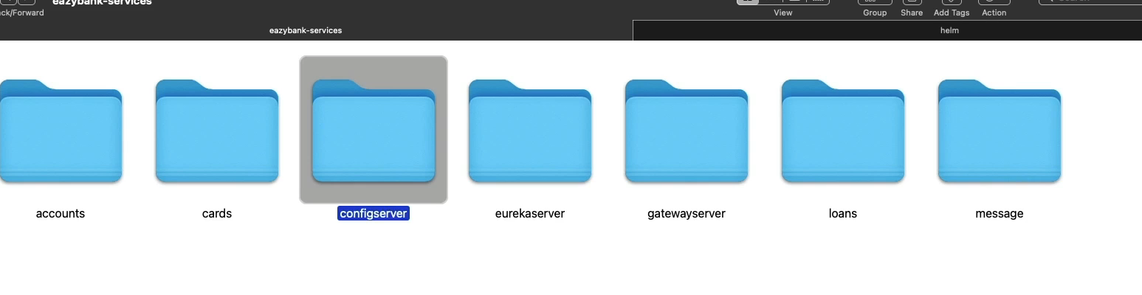

240) creating helm chart qa dev prod

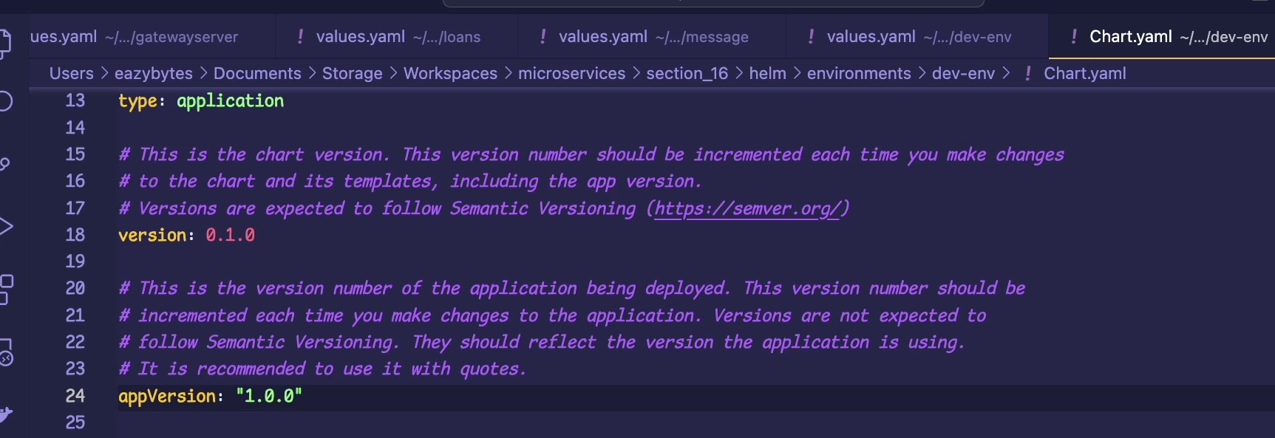

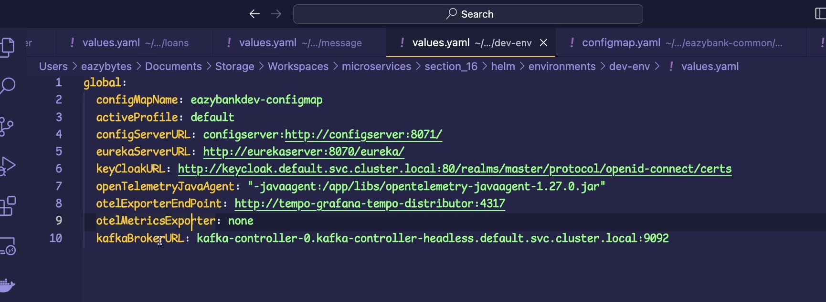

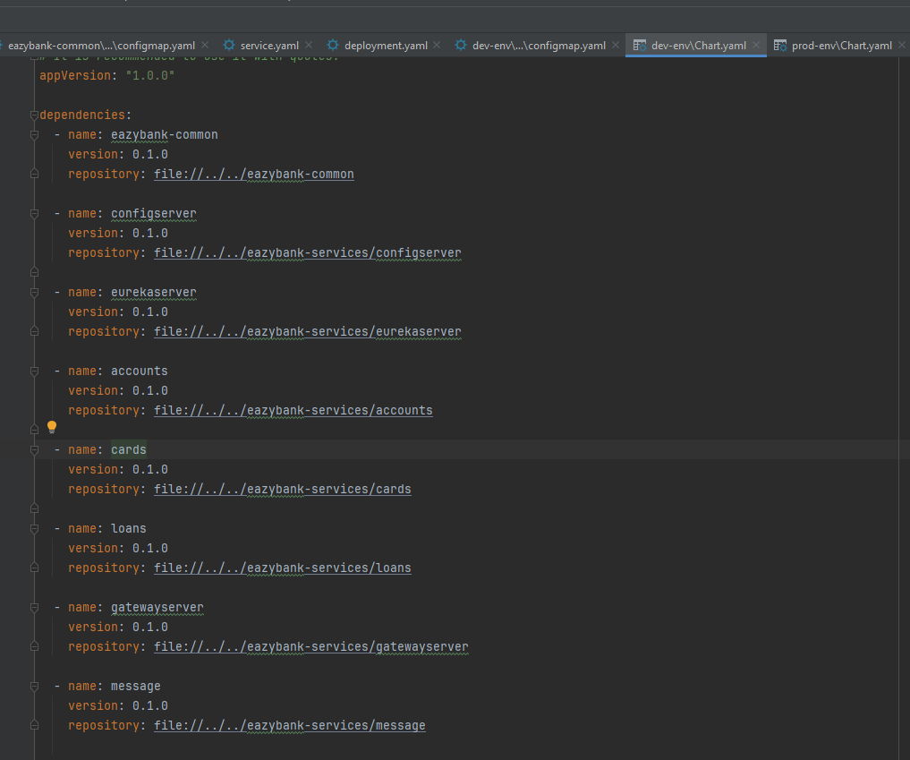

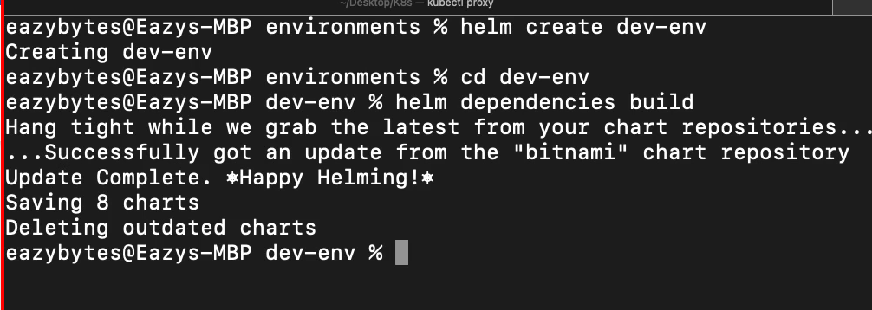

After building now in charts folder you can see all dependencies available in packaged format

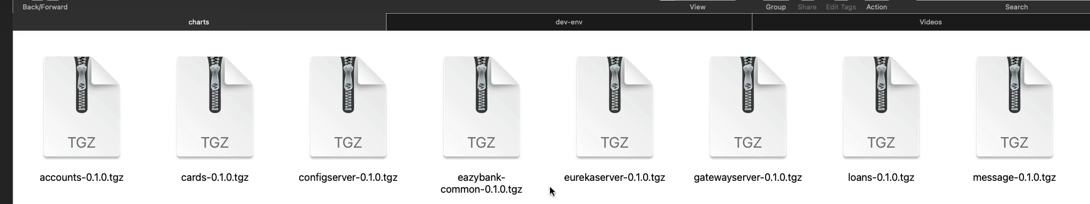

For qa & prod just copy and update values.yaml

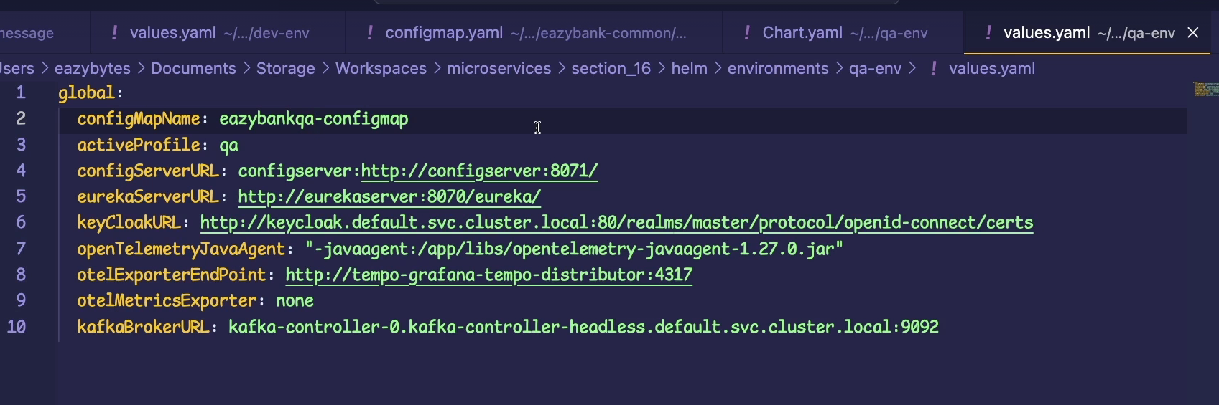

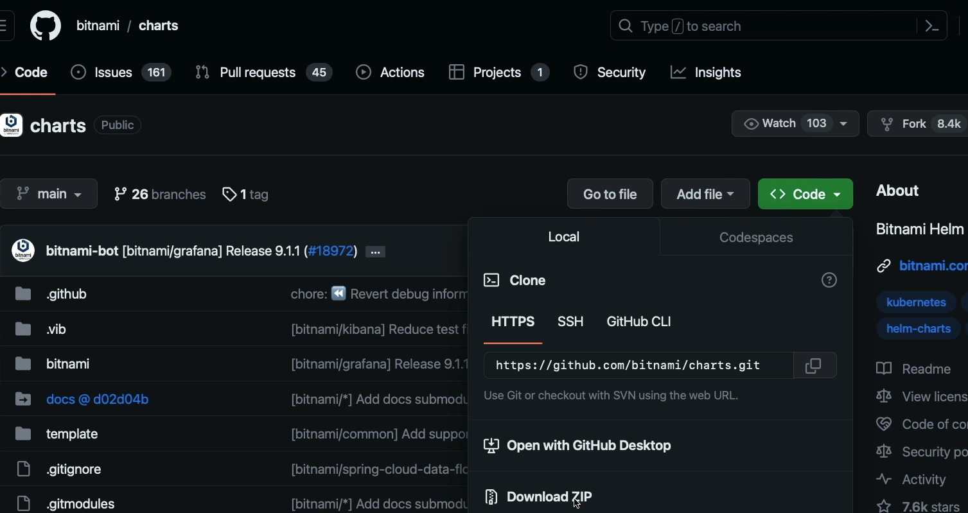

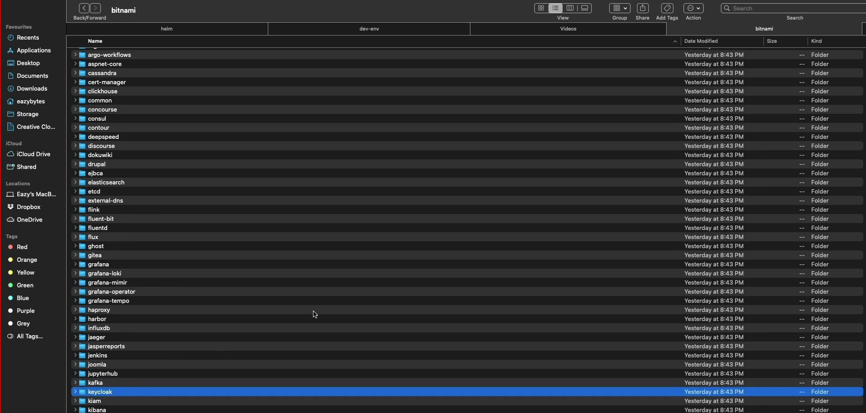

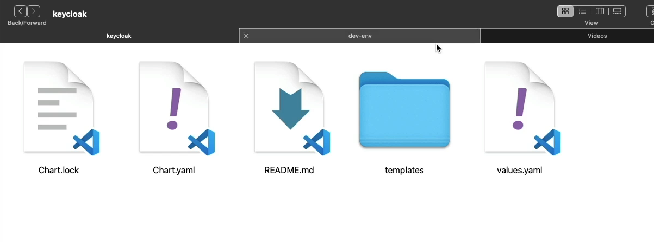

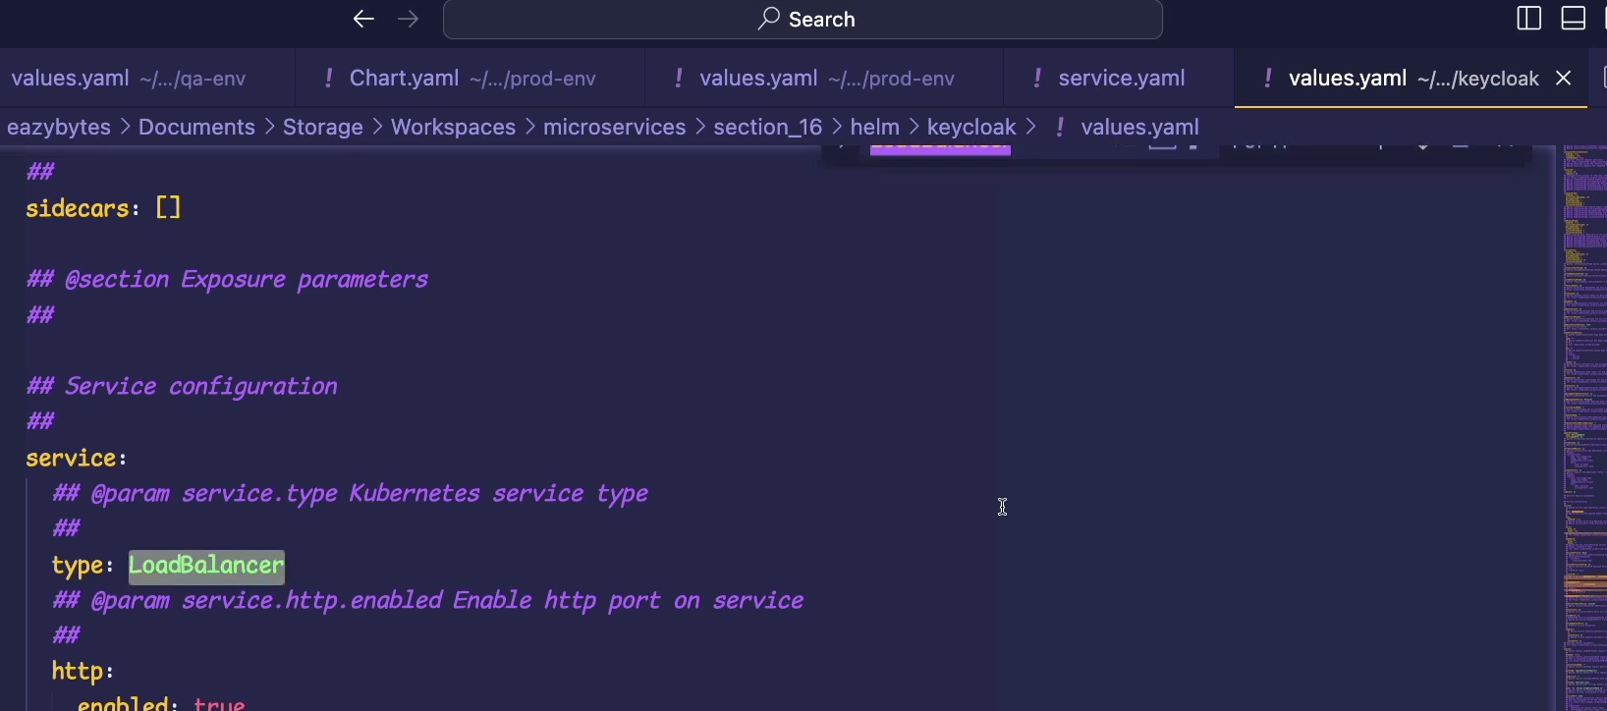

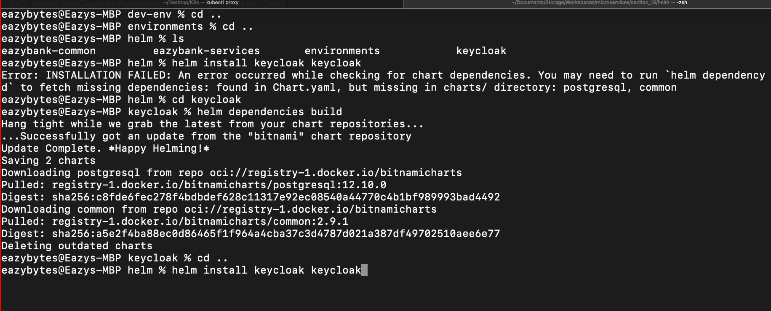

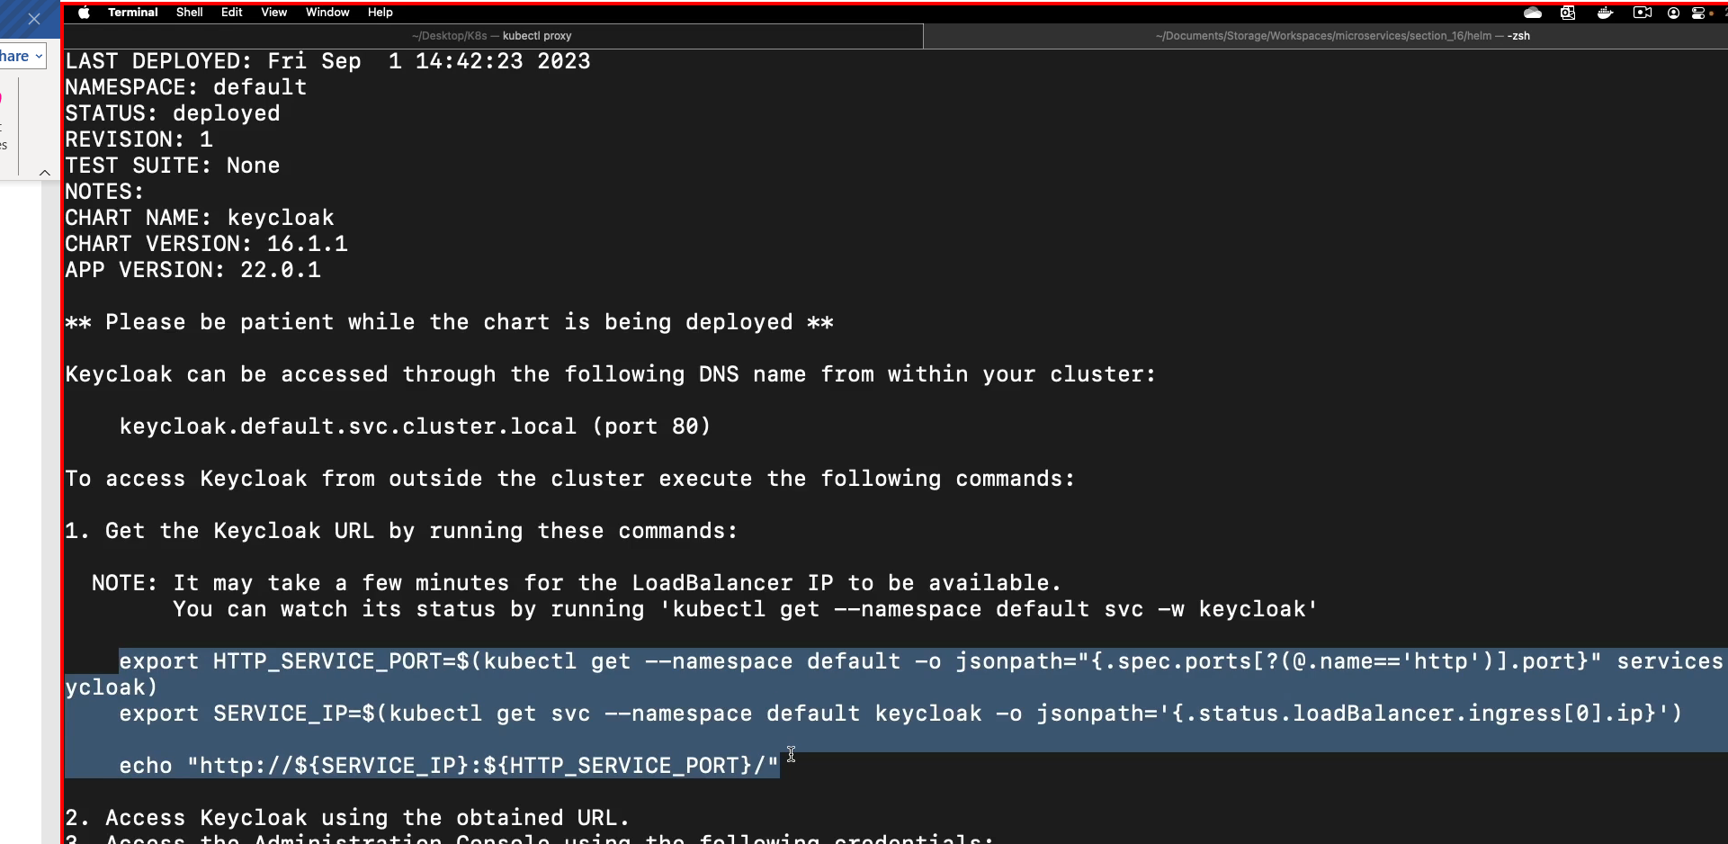



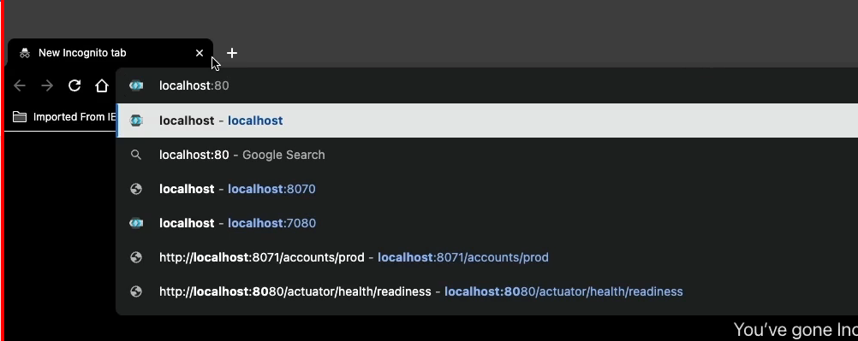

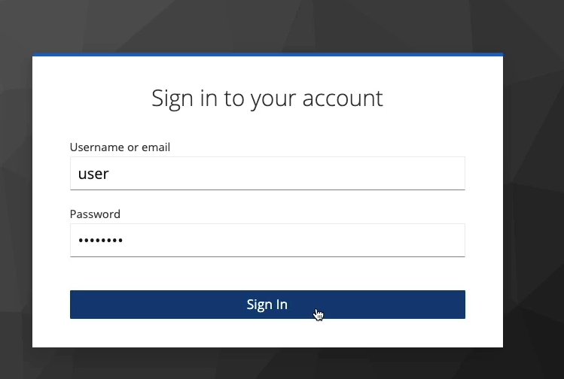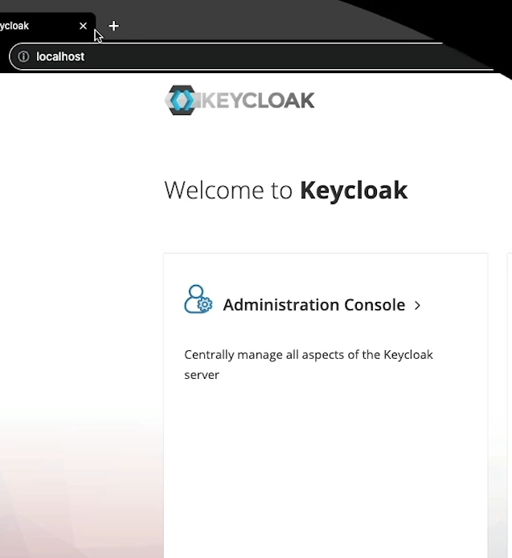

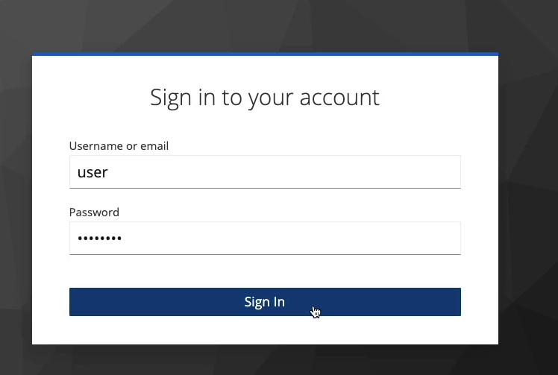

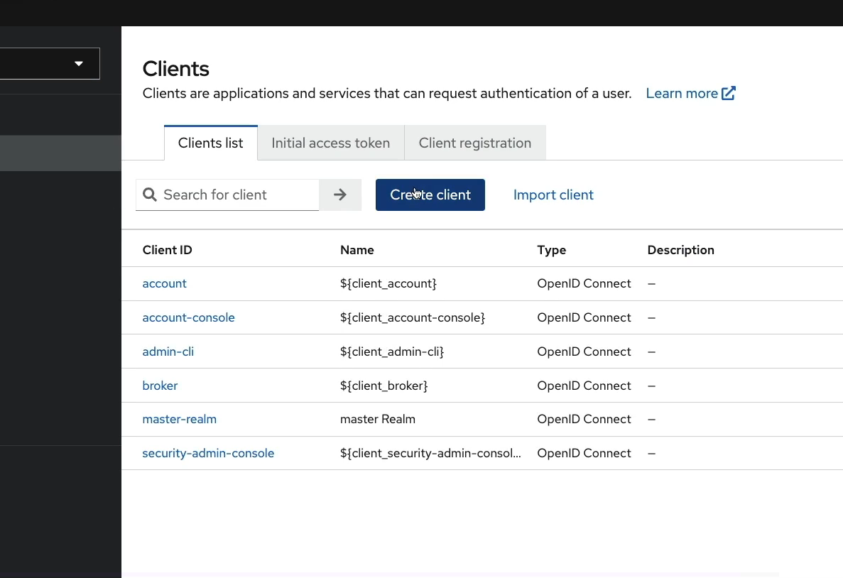

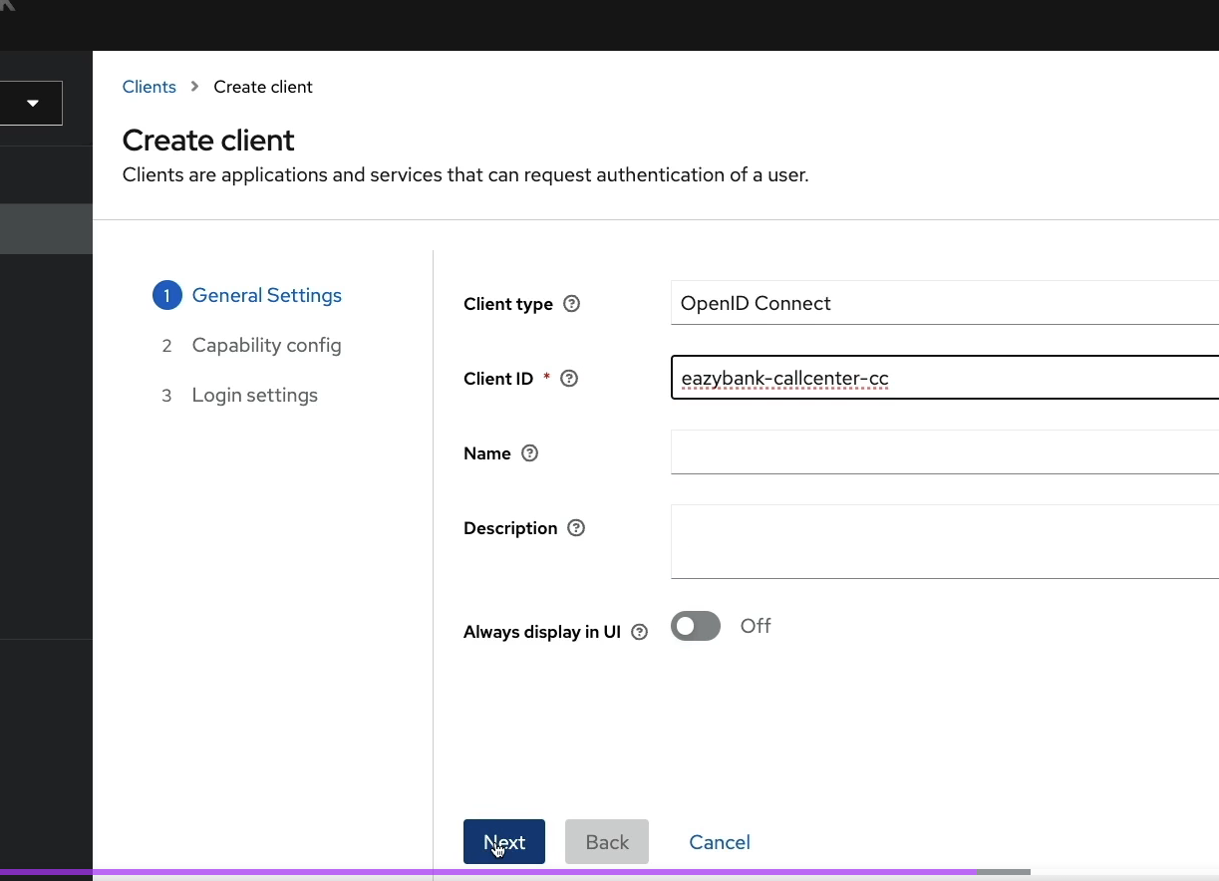  
  
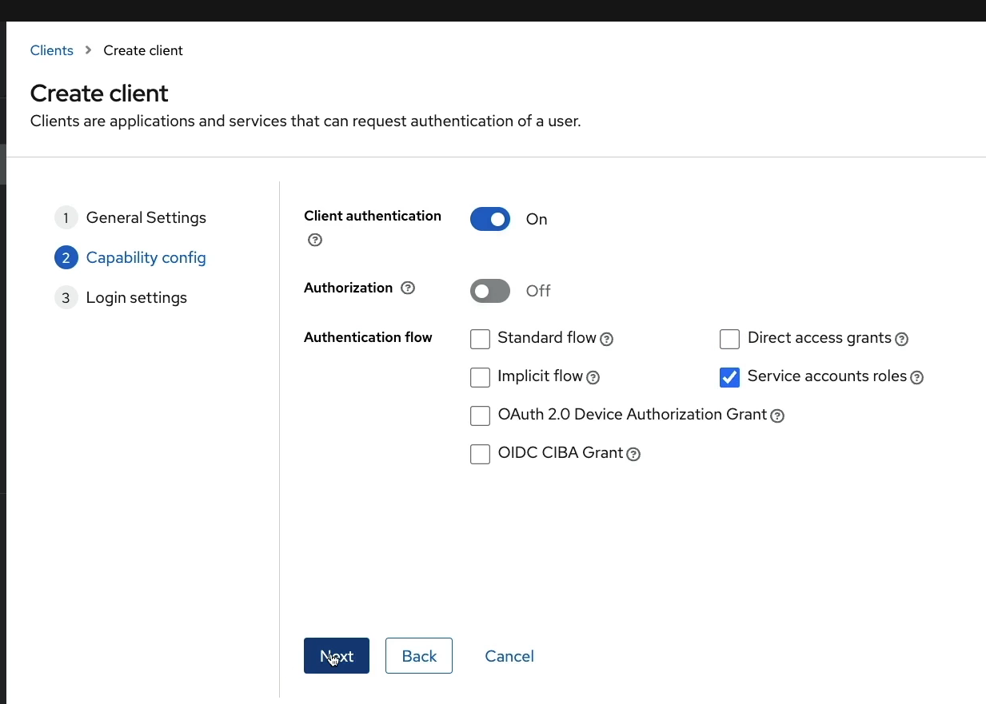

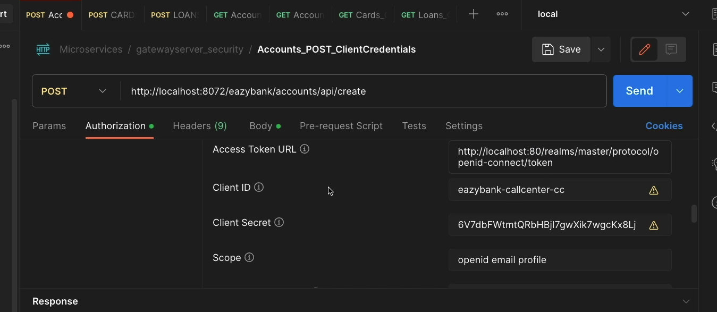

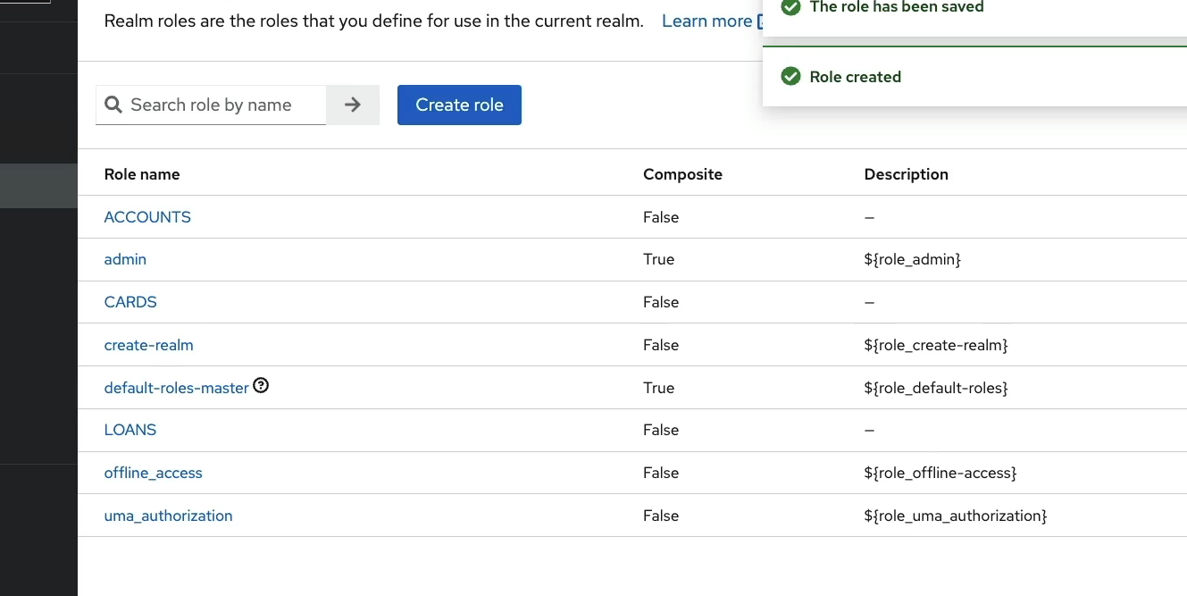

Create cards and loans

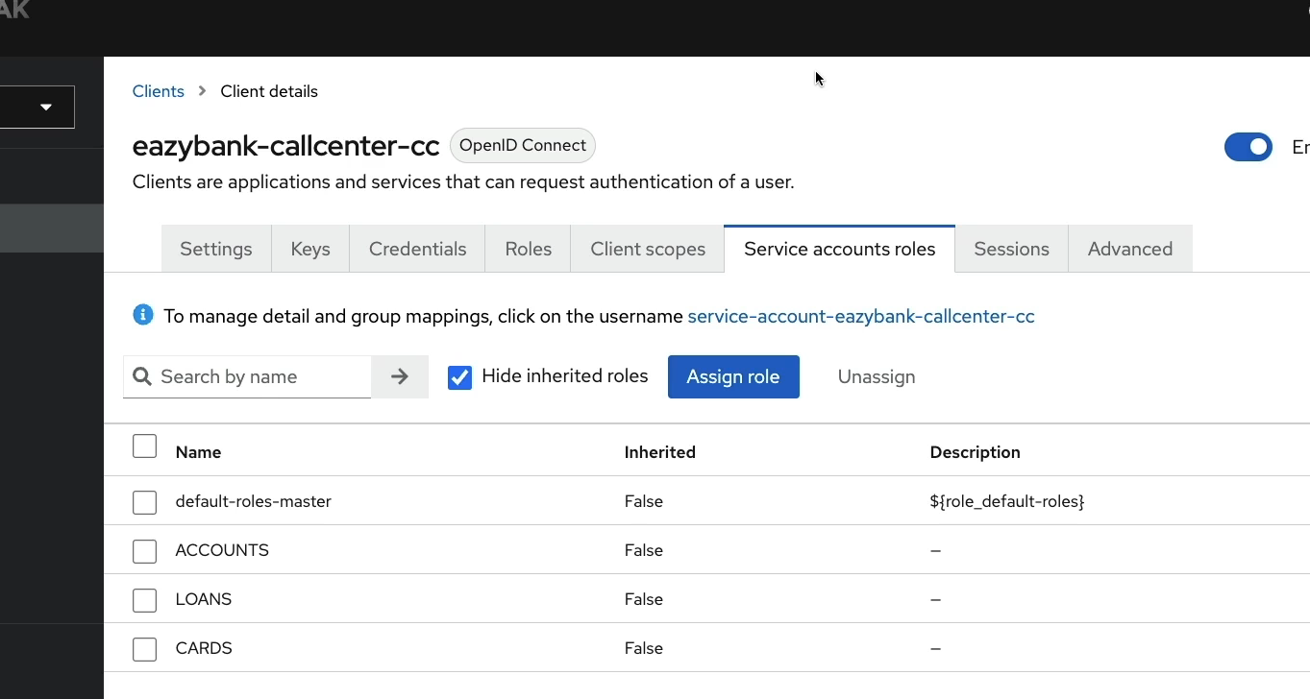

243) setup kafka with helm chart

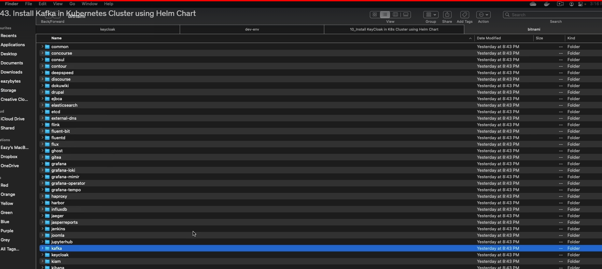

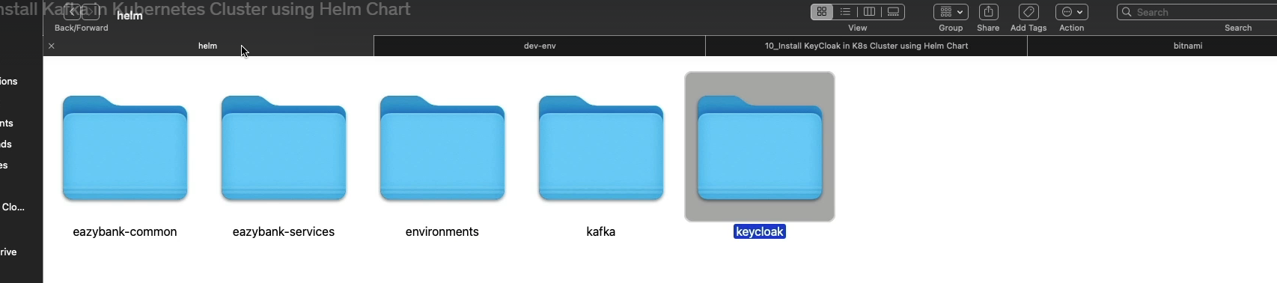

Paste the kafka in above location

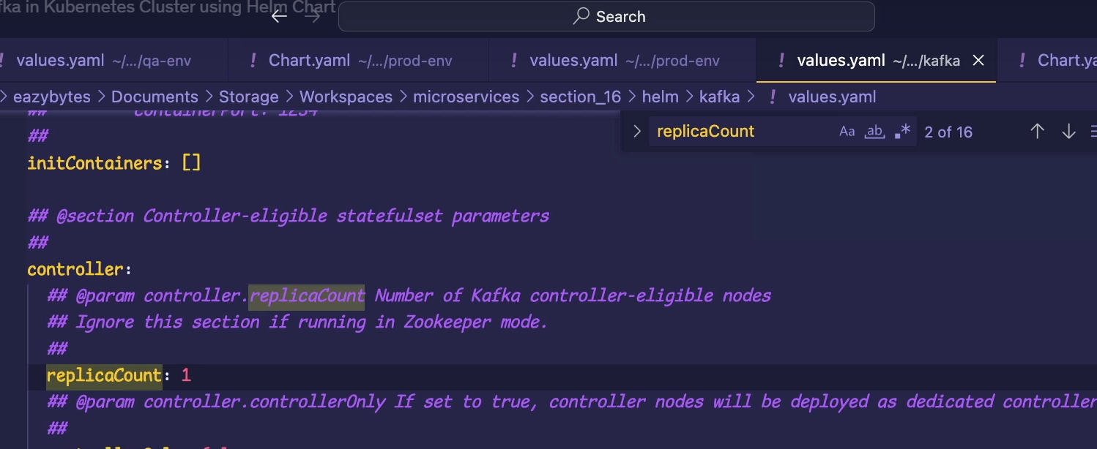

Replace sassl_plaintext with plaintext, this is chainging security

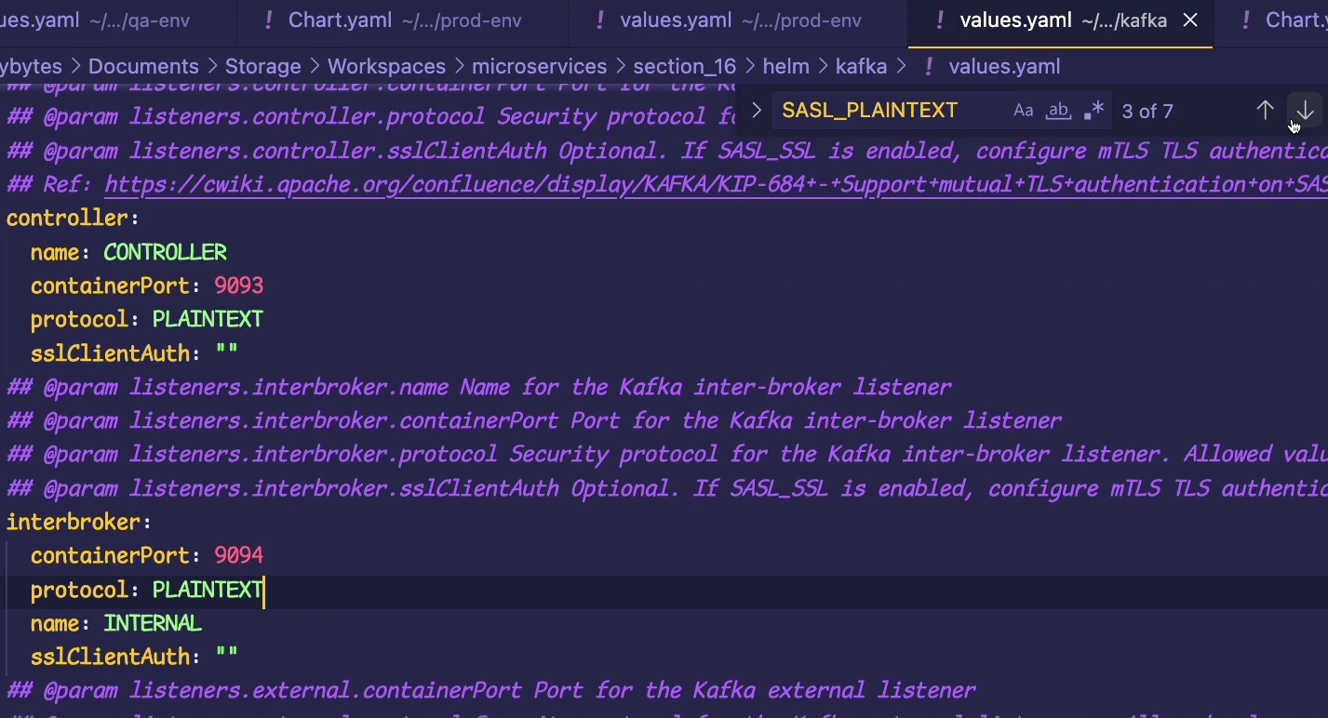

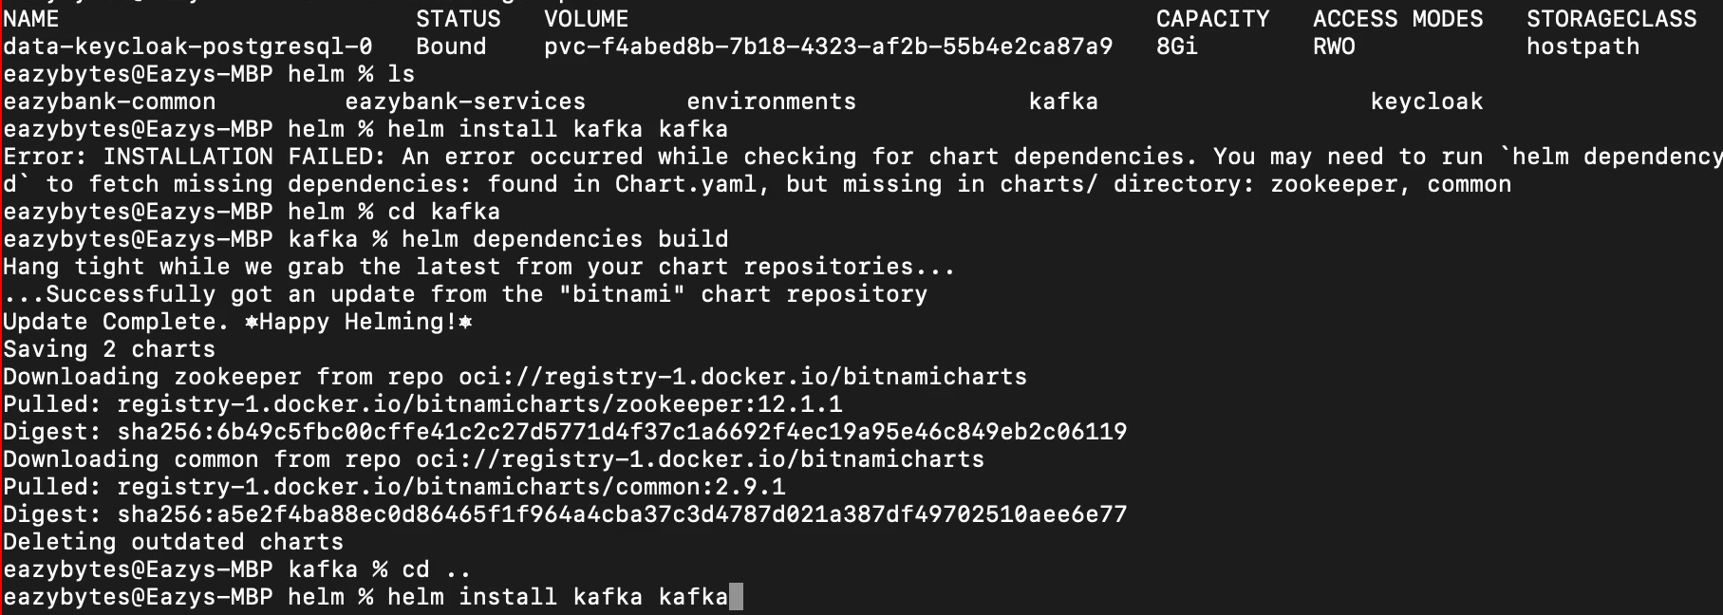

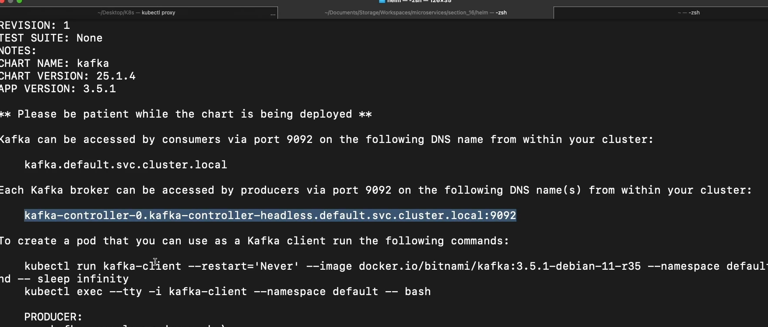

244) promethus

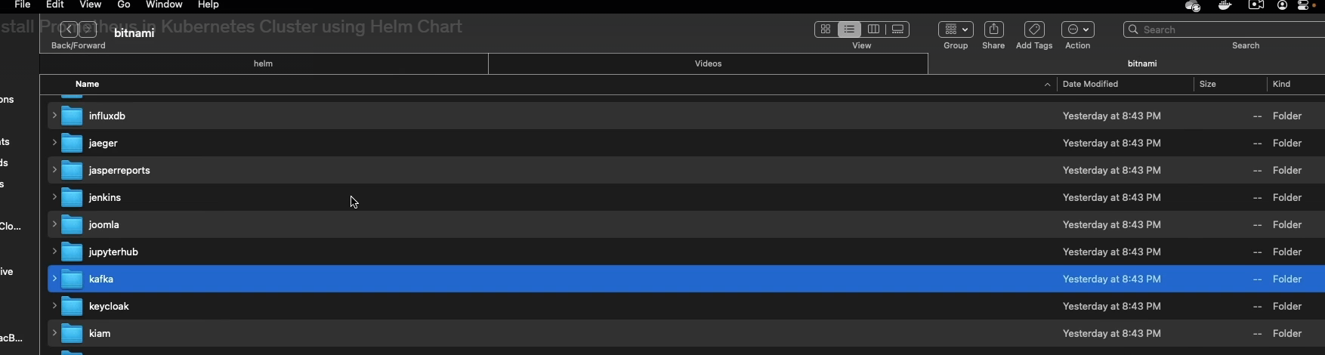

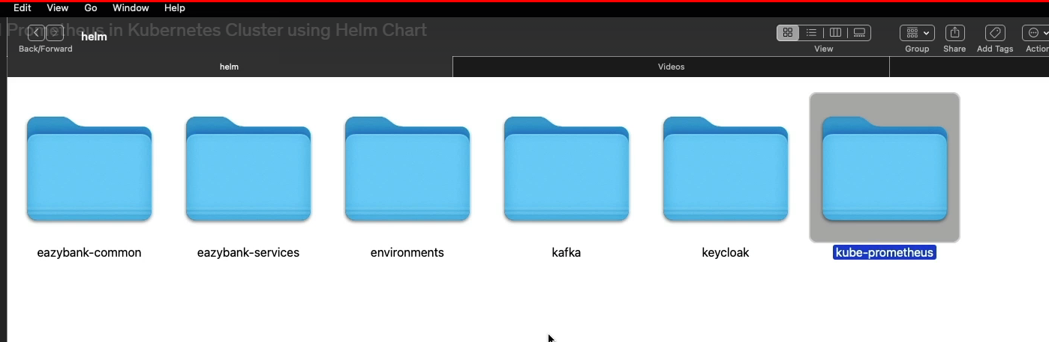

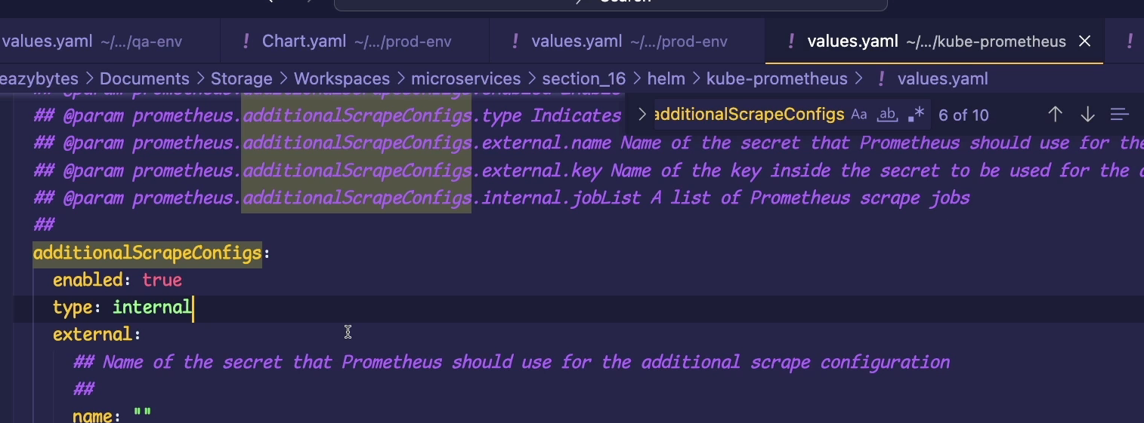

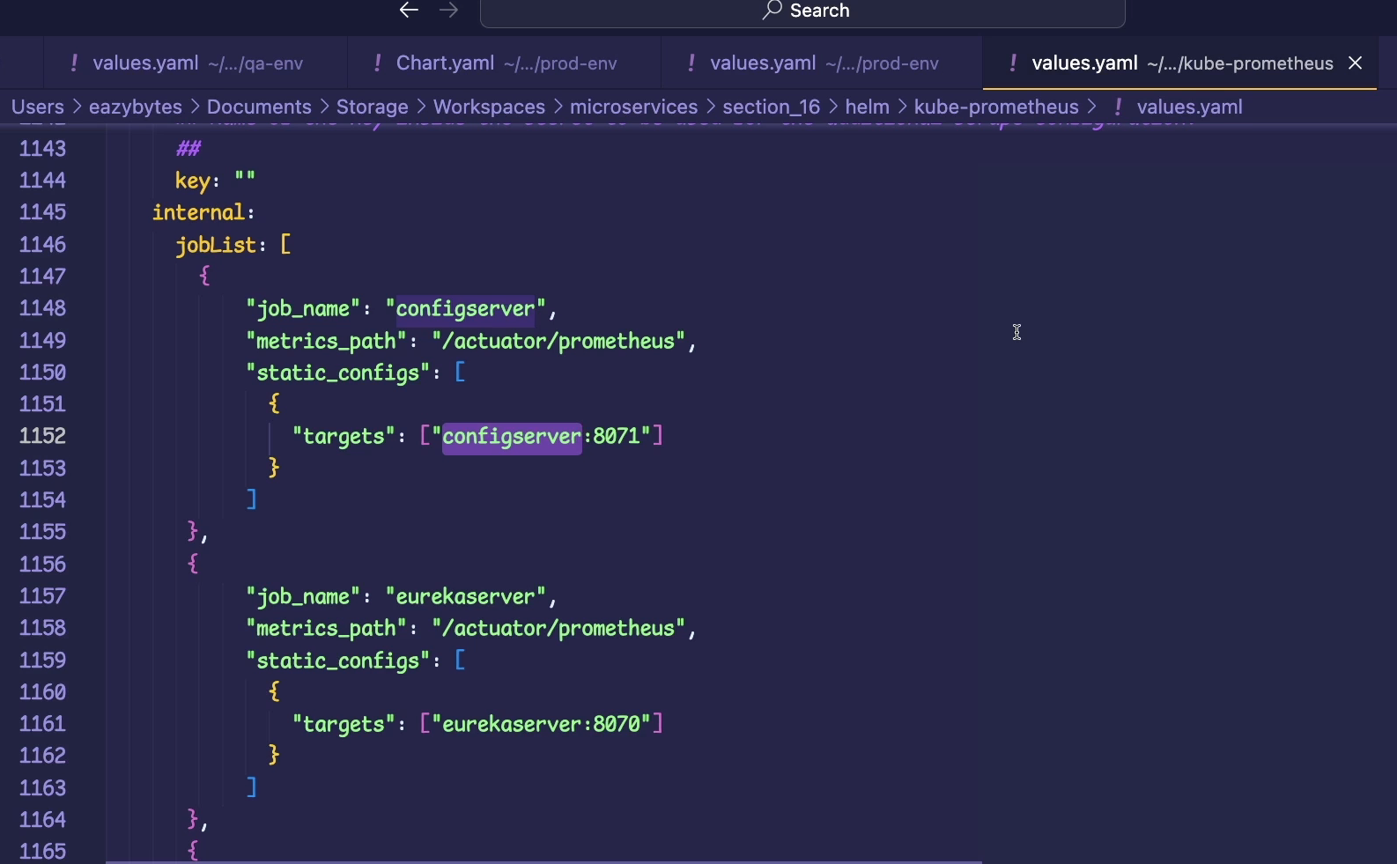

Menthoion job list for each ms

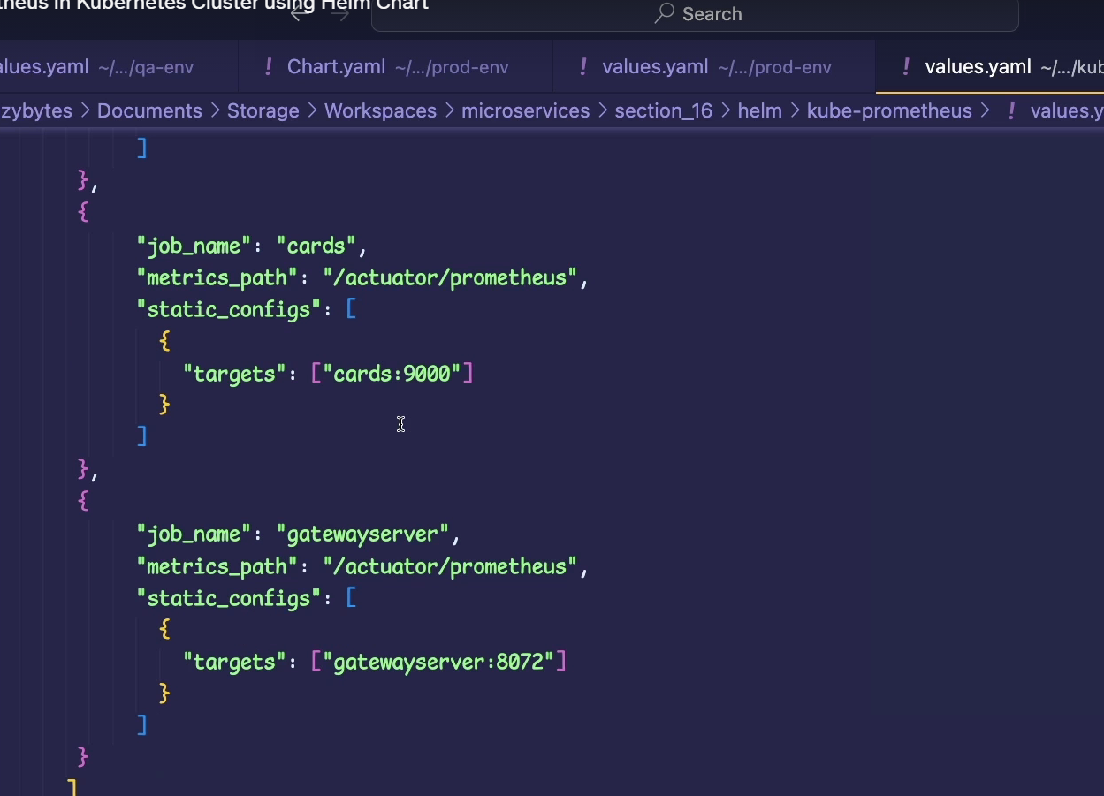

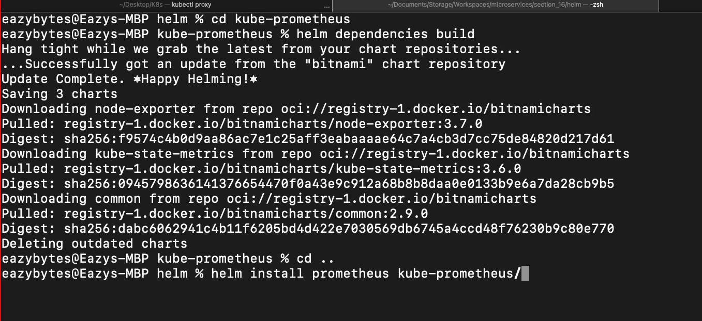

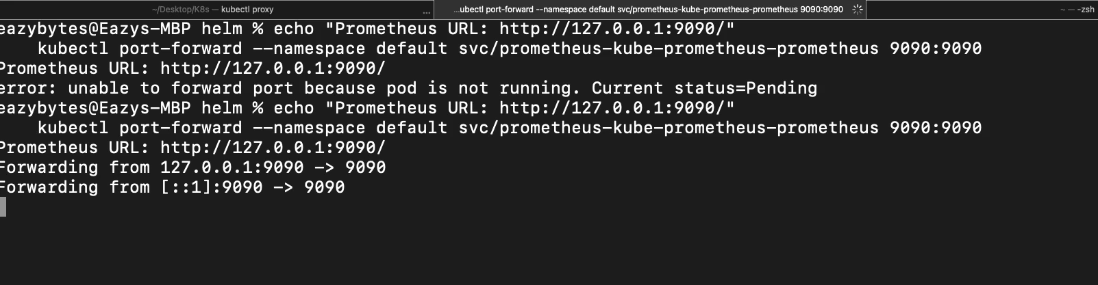

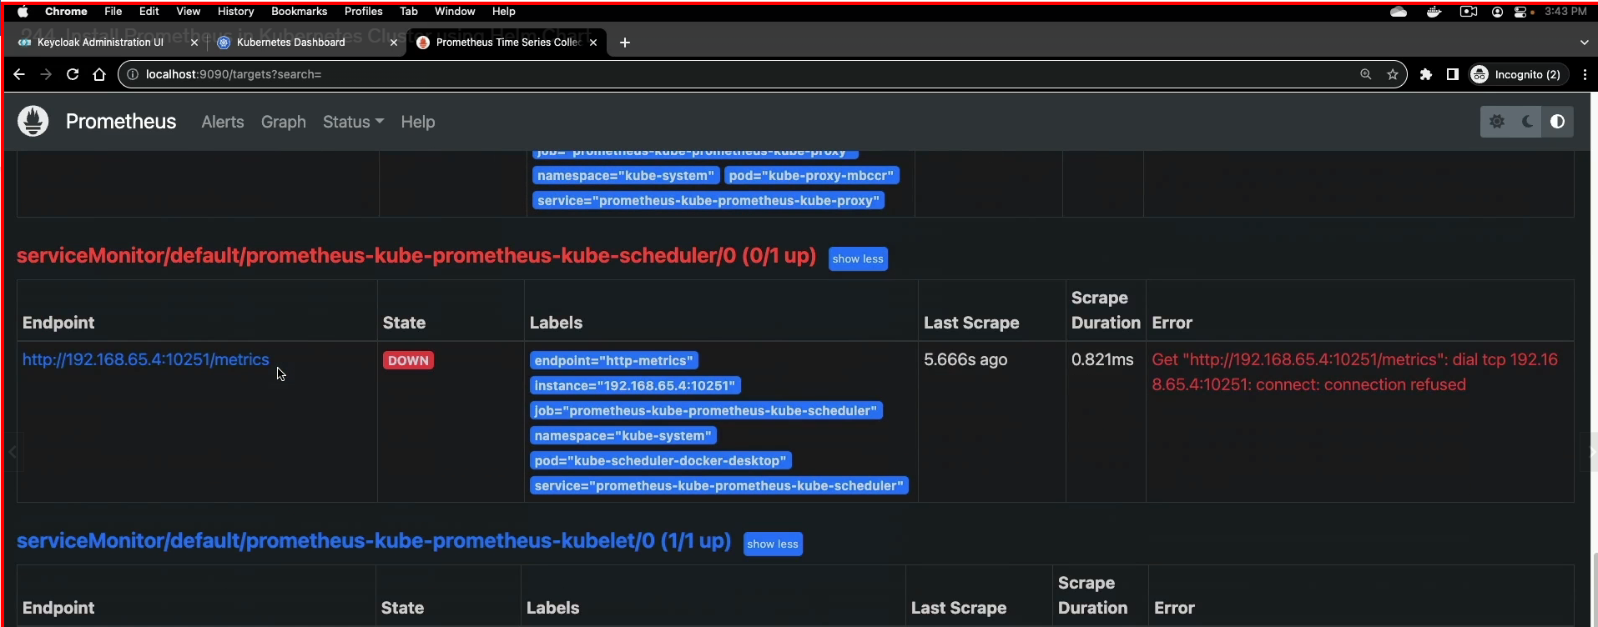

245)

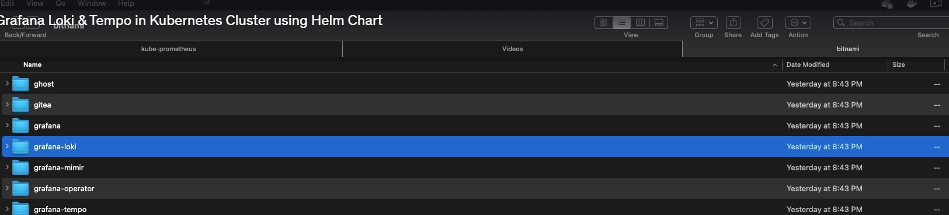

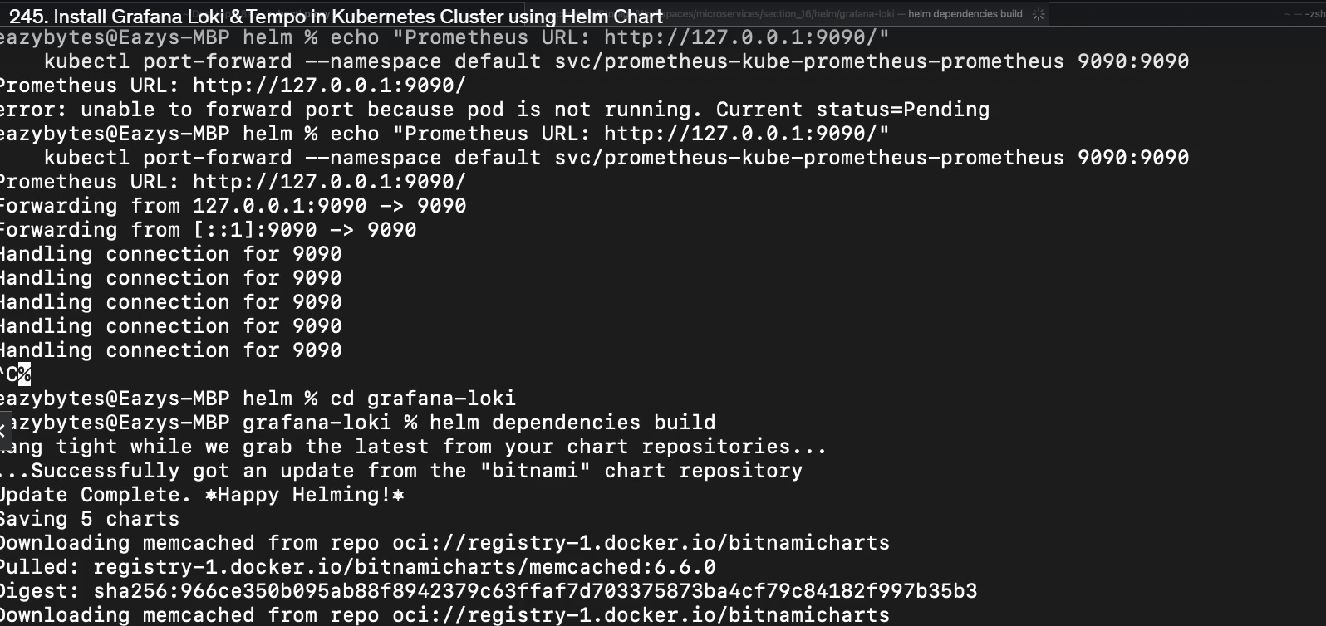

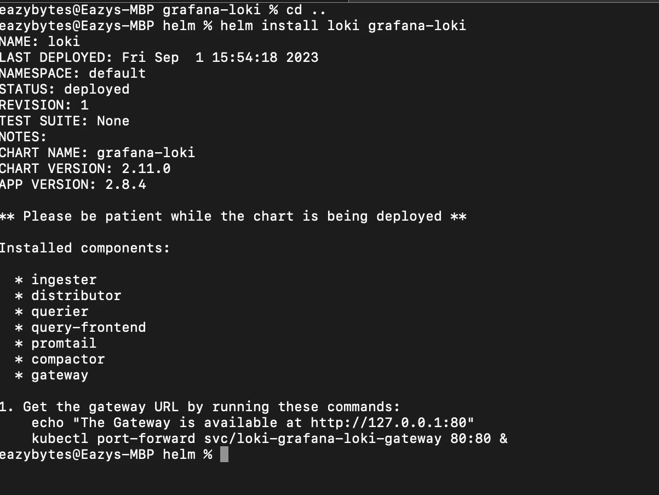

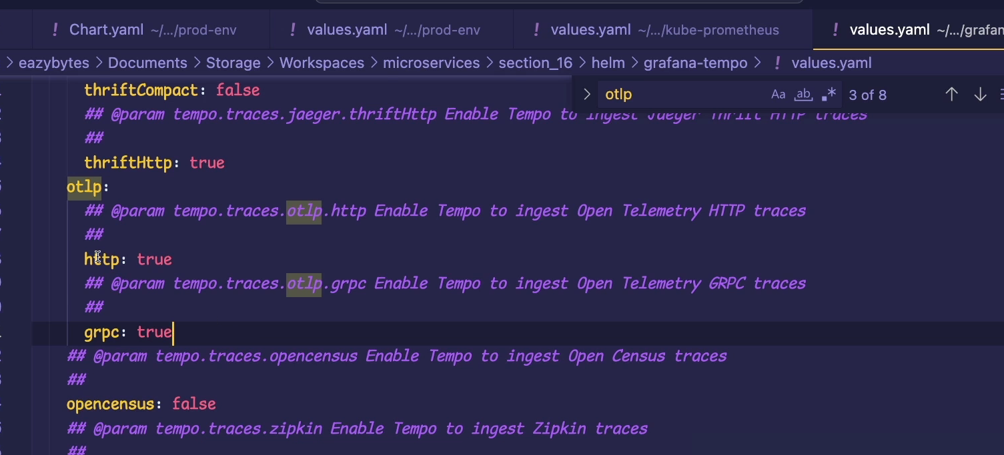

247) deploy microservice in to prod-env

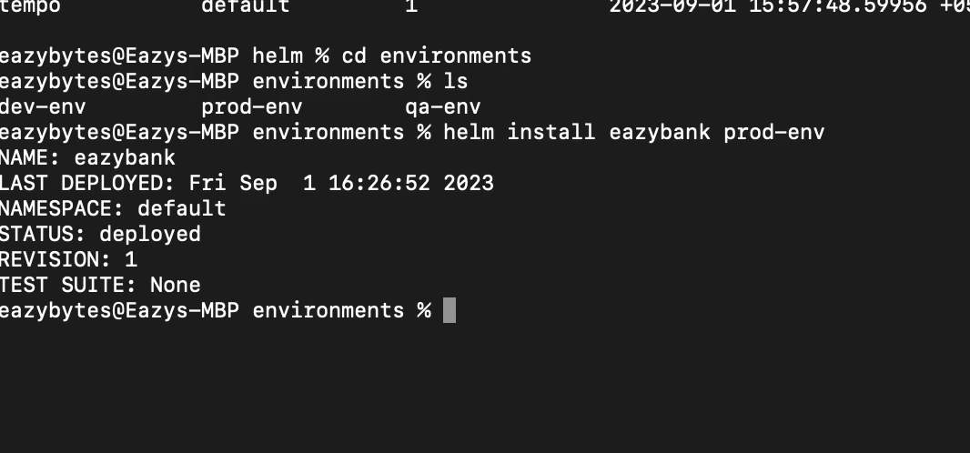

Now once ´prod started you can see all ms started and all other like Grafana prmoethus etc

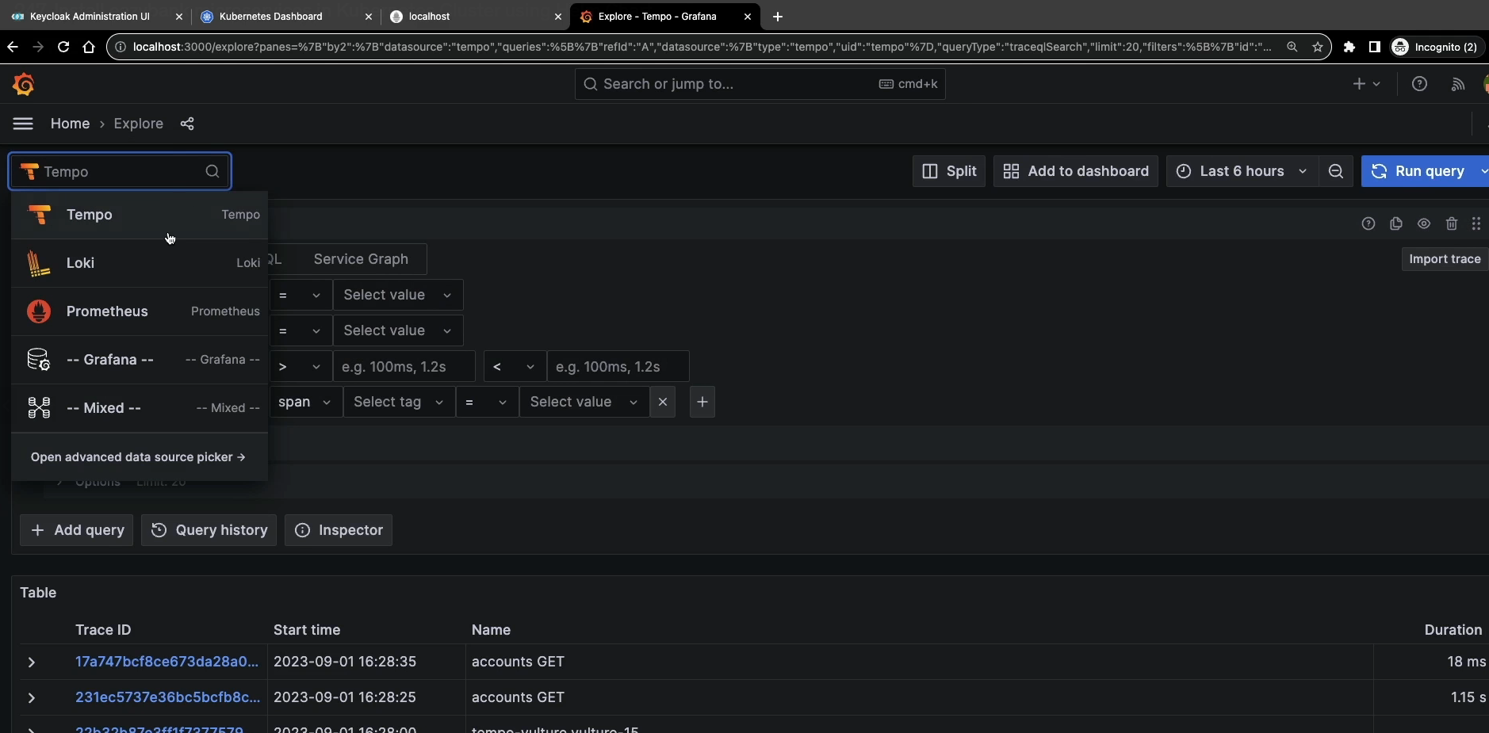

248) demo helm upgrade command

Go to prod env folder

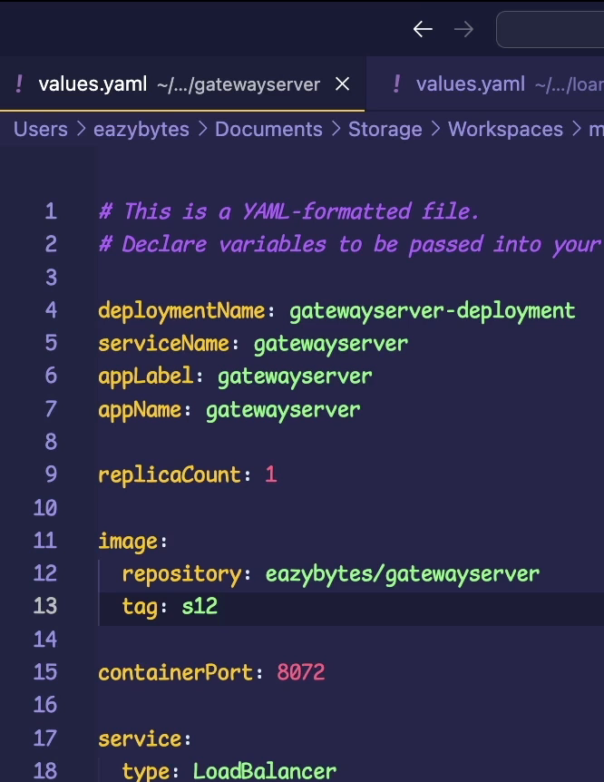

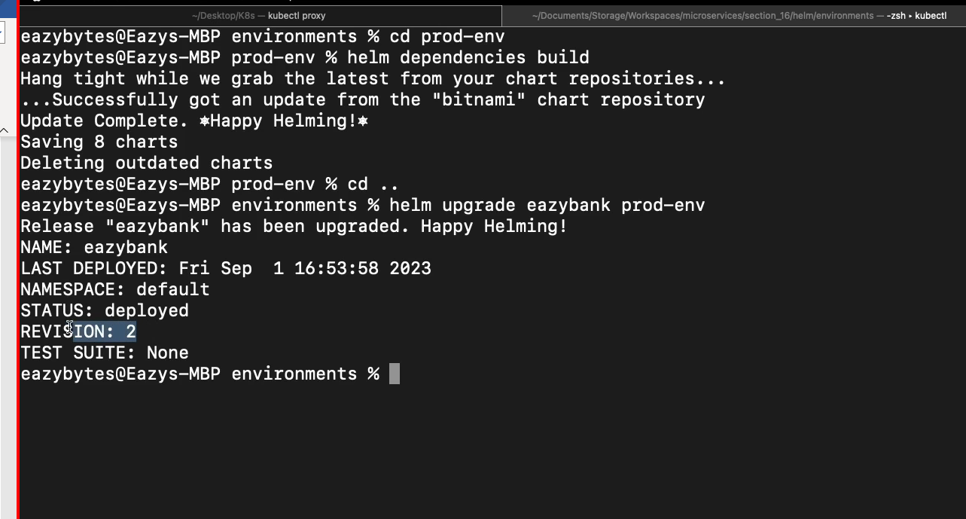

249) helm history and rollback commands

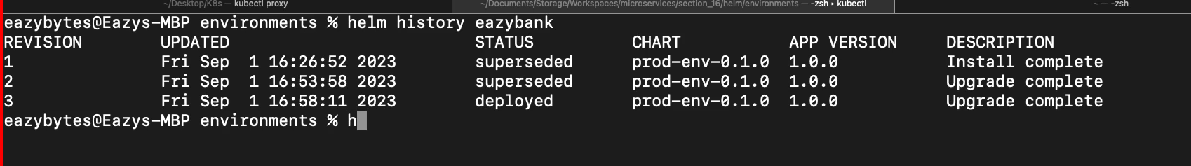

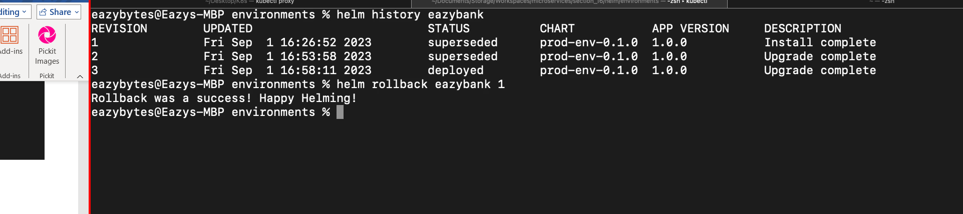+

250) unistall helm

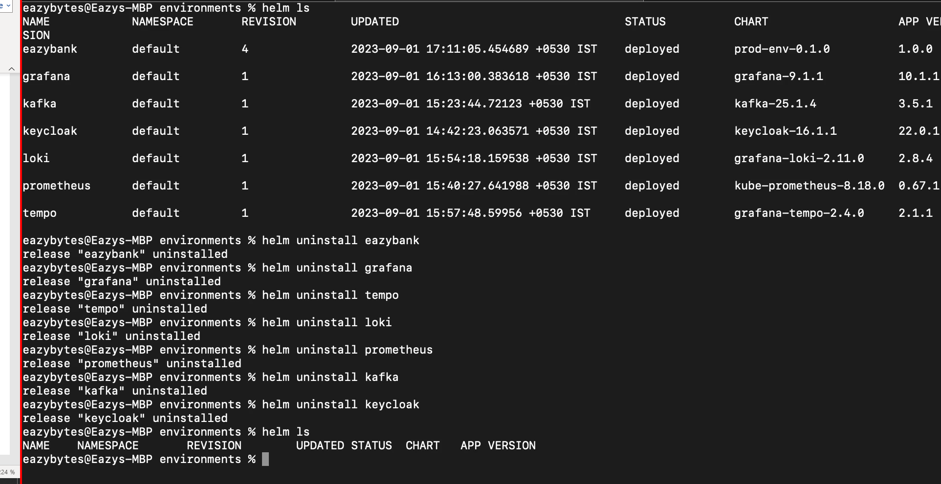

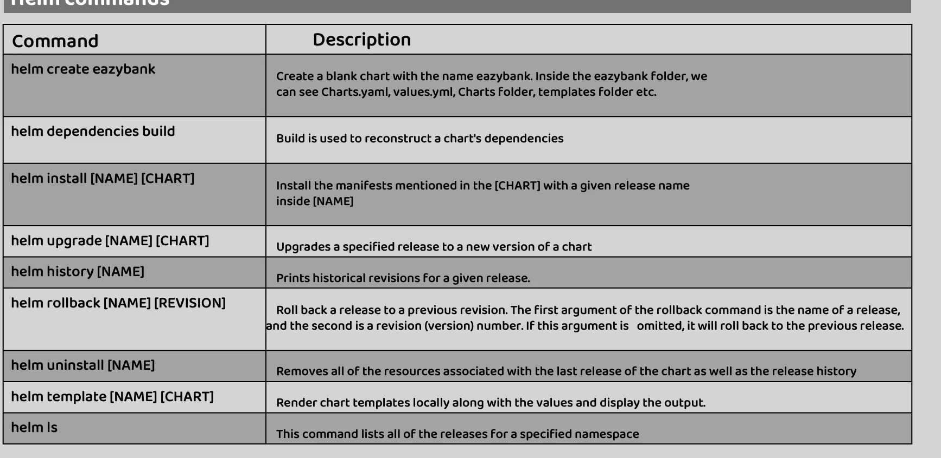

const updateComponentModel: UpdateComponentModel = {  
 componentKey: 'testComponentKey',  
 kind: 'testKind',  
 lifecycle: 'testLifeCycle',  
 projectKey: 'testProjectKey',  
 token: ***TEST_TOKEN***,  
 type: 'testType',  
};

